Spring Security 1

1) Simple Security Configuration 1

2) Simple Security Configuration – with user name and password in application.properties 3

3) Spring Security Architecture 3

4) Customize security- custom user name and password – in memory databasae: 4

5) Customize security - with users detail in the database 6

6) Custom security with custom login page 7

7) Disabling and surpassing security 7

8) What happen if we don’t define any passwordEncoder? 7

9) Understanding configure methods of WebSecurityConfigurerAdapter 9

10) How to permitAll/ denyAll the given request? 10

11) UserManagement in spring: 11

Oauth 2.0 12

12) Problem without oAuth2.0 12

13) What is OAuth2: 14

14) Different Components in OAuth 2: 14

15) Various type of grants 18

16) Spring boot security with github as Auth server 18

17) How to create Resource server? 18

18) How to create Auth Server? 18

Reference 18

# Spring Security

## Simple Security Configuration

### In order to add security to our Spring Boot application, we need to add the security starter dependency:

### <dependency>

### <groupId>org.springframework.boot</groupId>

### <artifactId>spring-boot-starter-security</artifactId>

</dependency>

### application will prompt for user name and password; user name is user and password is printed on console.

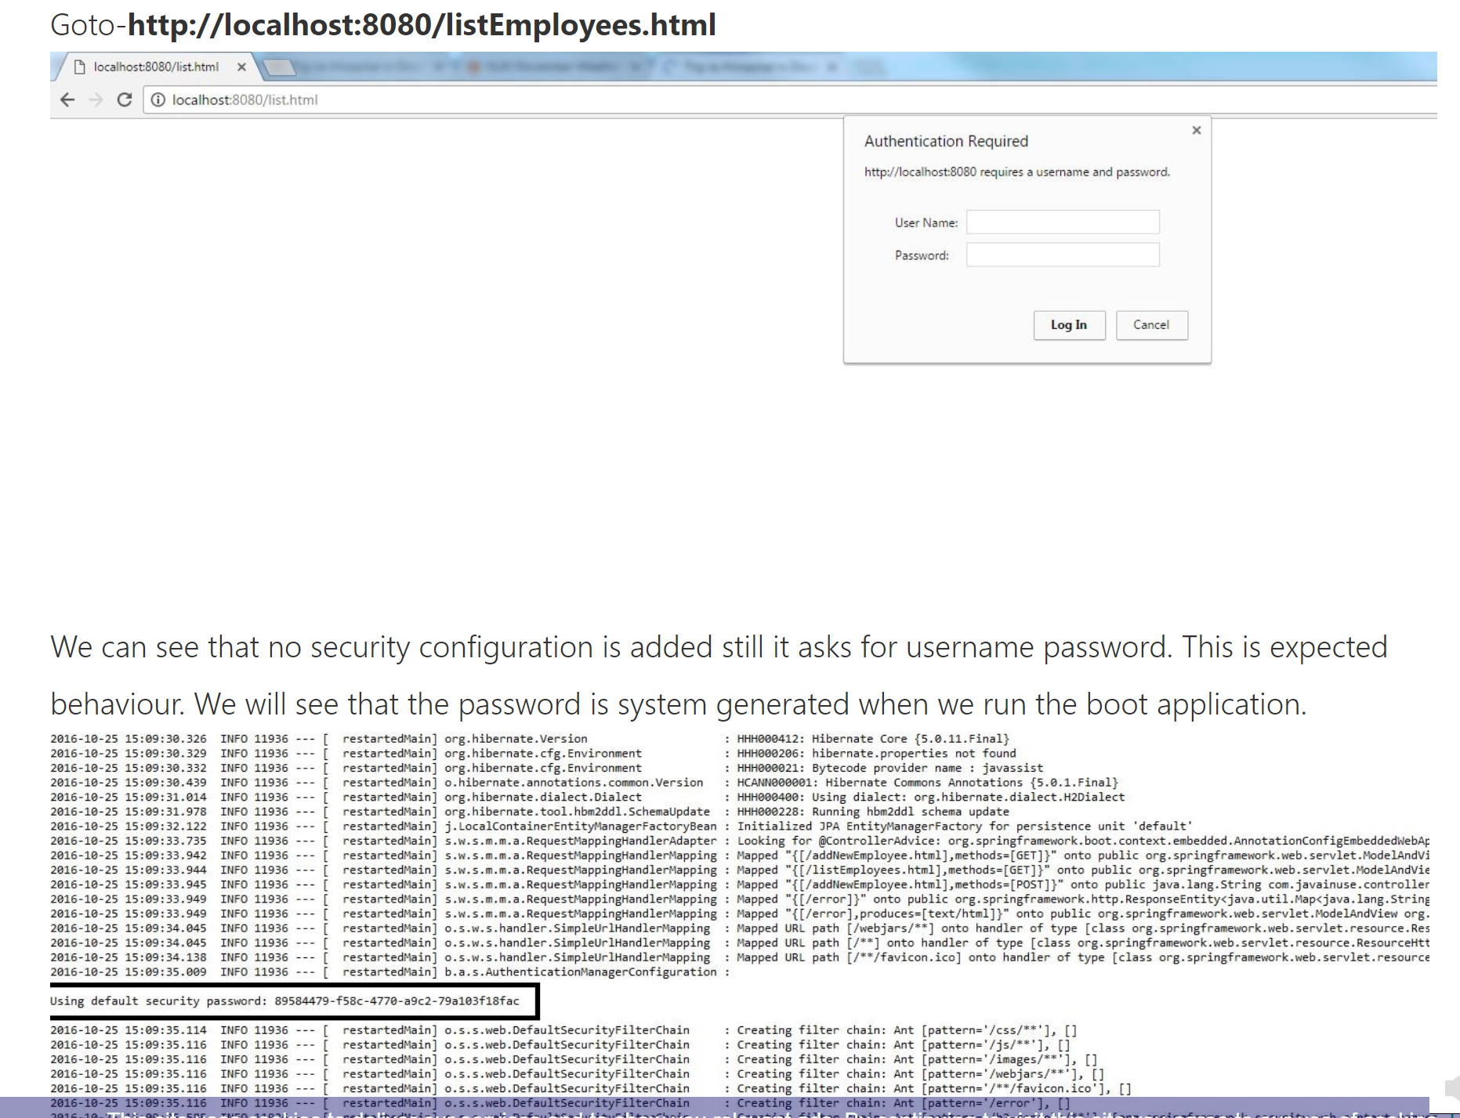

### Thus by just adding the spring boot security starter dependency the basic security has already been configured by default.

### This all happens because of SecurityAutoConfiguration class, which is included by default by adding jar/ pom entry.

## Simple Security Configuration – with user name and password in application.properties

### All steps same as mentioned above.

### There are some predefined properties, such as:

### Spring.security.user.name

### Spring.security.user.password

### If we don’t configure the password using the predefined property *spring.security.user.password*and start the application, we’ll notice that a default password is randomly generated and printed in the console log. If we defined these property in application.properties file, no password will be printed on console. And we can use our password, whatever we have given in prop file, for example – user name – admin, password – test

### Spring.security.user.name=user

### Spring.security.user.password=test

## Spring Security Architecture

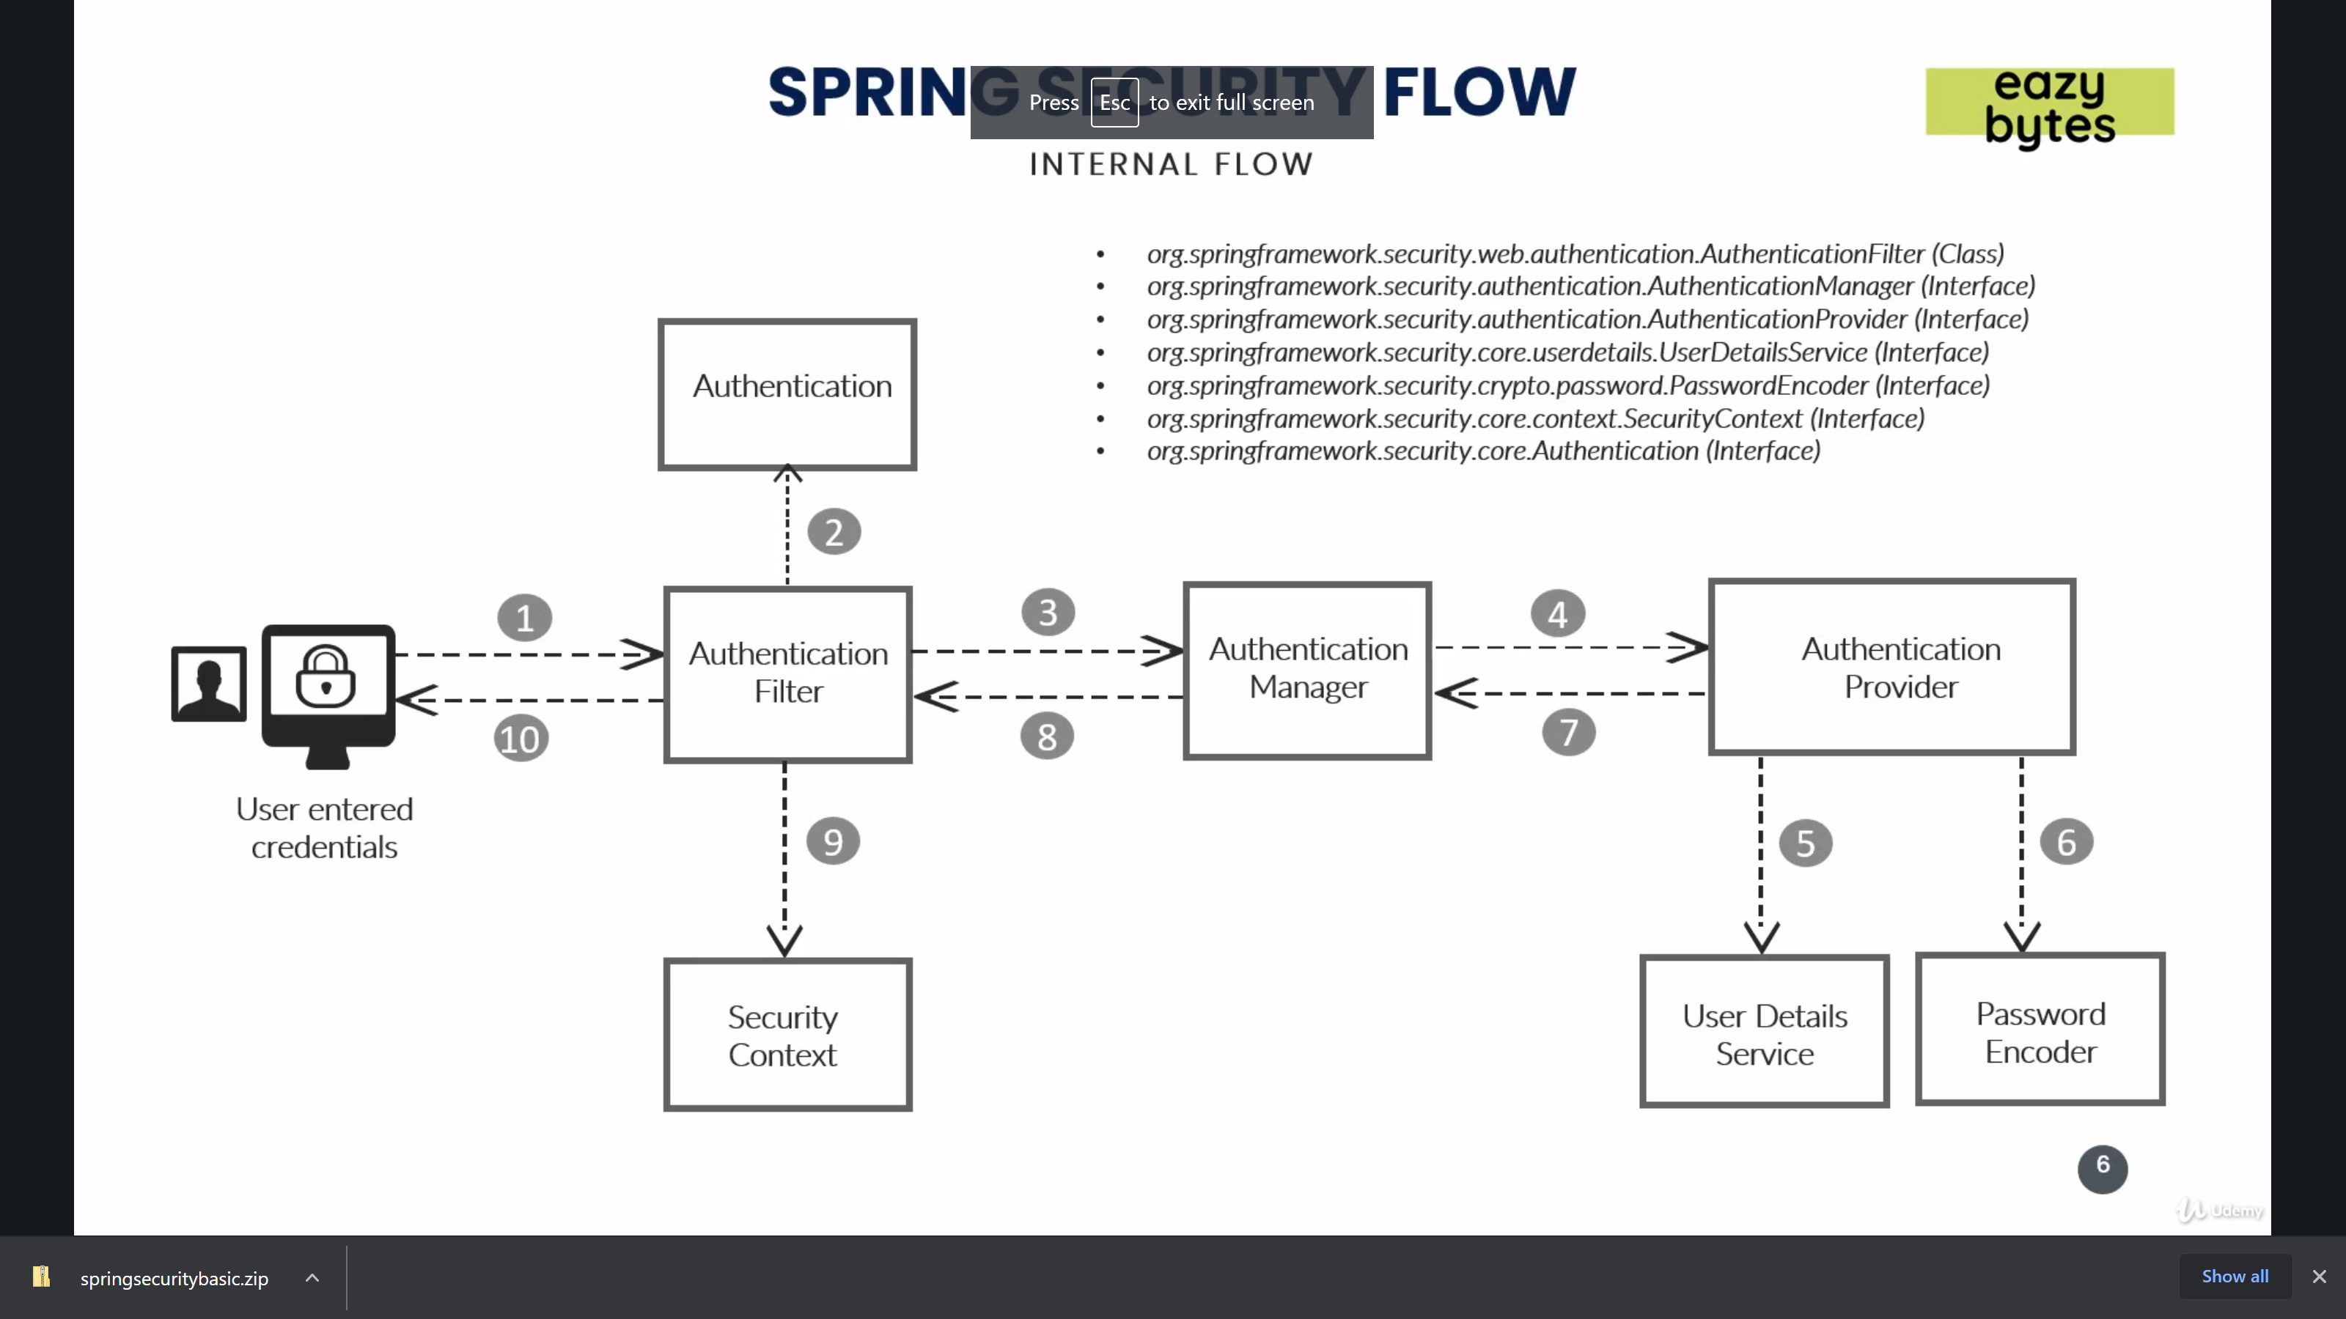

### 1) user send credentials.

### 2) Spring Authenticationfilter take the details and create Authentication Object.

### 3) Authentication Object is passed to Authentication manager.

### 4) authentication manager will identify the correct implementation of authentication provider (inmemory, database, ldap, caas, Oauth or so on)

### 5) all biz logic is implement here in authentication provider.

### 6) provider use UserdetailsService and Password encoder. Userdetailsservice tells the schema of User (username,pwd, otp, email etc). password encider says how to encode/decode the pwd

### Spring provide multiple imbuilt pwd encoders.

### 7)After validating the user, Authentication Object is modified, which contains the user role and authorities ; this is passed back to Authentication manager.

### 8) manager pass this to filter.

### 9) filter add this to SecurityContext of Spring.we store the data of user , once validated , to the seccurity context. Because when second time request will come then it will go to the security context and not follow the above mention path.

## Customize security- custom user name and password – in memory databasae:

### For customization – Create a class that extends **WebSecurityConfigurerAdapter** class.

### Use @EnableWebSecurity annotation on this class which extend WebSecurityConfigurerAdapter

### There are 2 ways –

### Override 2 Configure methods – one takes httpSecurity an authenticationManager Builder

### Override userDetailsService() method

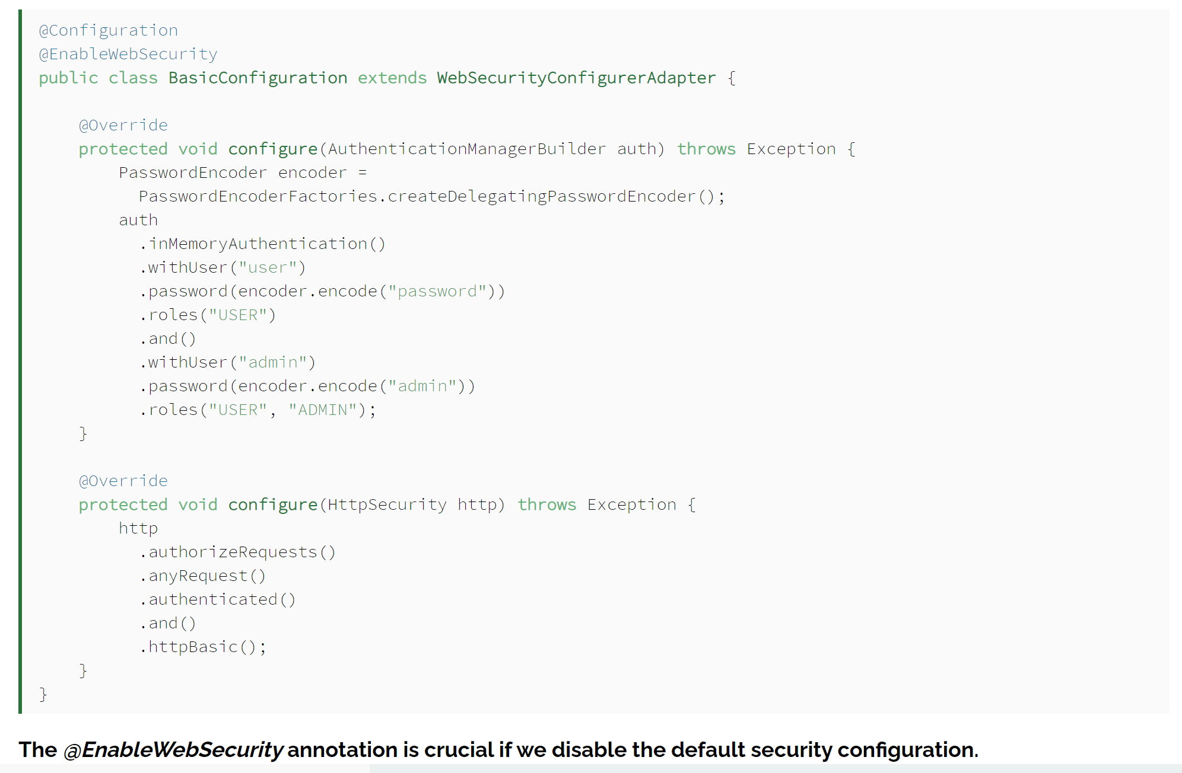

**OR**

InMemoryUserDetailsManager – way1

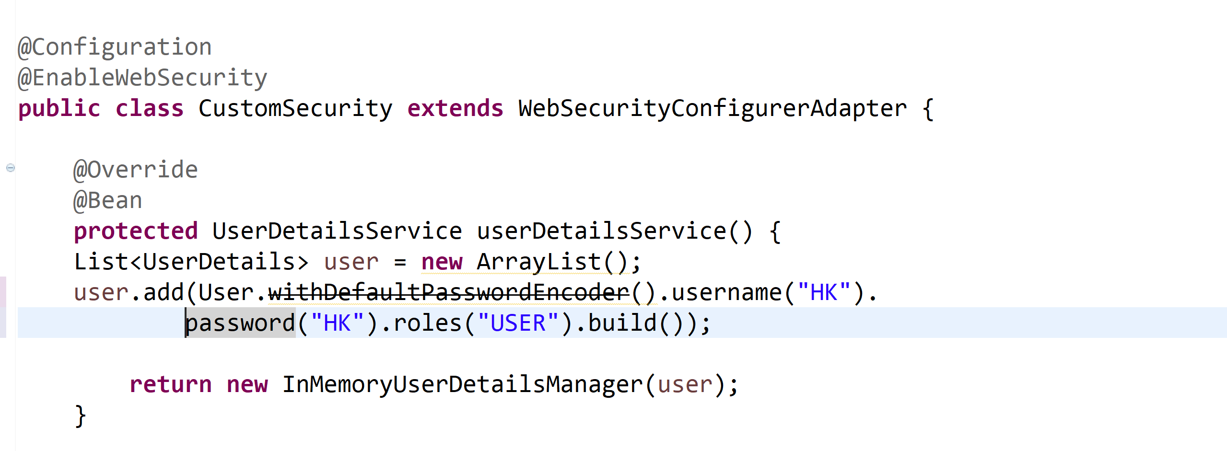

**OR**

Using InMemoryUserDetailsManager – way 2

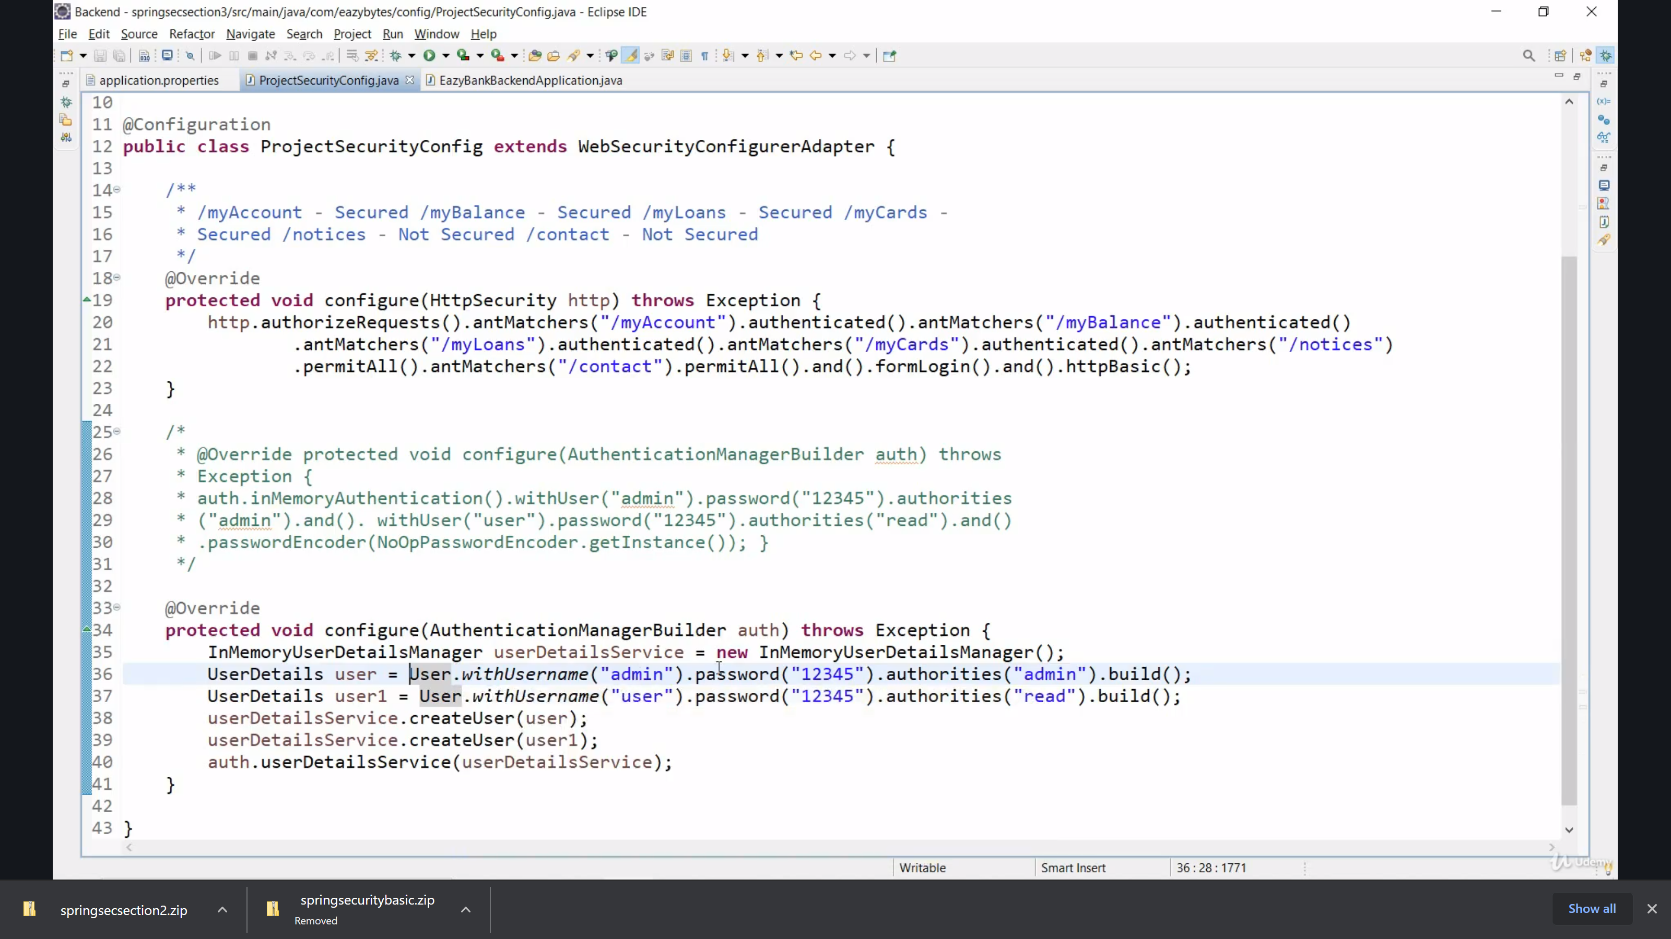

## Customize security - with users detail in the database

### Create a User Entity which saves username and password.

### Create UserRepository User user object.

### **public** **interface** **UserRepository** **extends** **JpaRepository**<**User**, **Long**> {

### User **findByUsername**(String username);

### }

### Create a class which implelments UserDedtailsServicec and override method – loadUserByName.

@Service

public class MyUserDetailsService implements UserDetailsService {

@Autowired

private UserRepository userRepository;

@Override

public UserDetails loadUserByUsername(String username) {

User user = userRepository.findByUsername(username);

if (user == null) {

throw new UsernameNotFoundException(username);

}

return new MyUserPrincipal(user);

}

}

### Define MyUserPrinicipal as follows-

**public** **class** **MyUserPrincipal** **implements** **UserDetails** {

**private** User user;

**public** **MyUserPrincipal**(User user) {

**this**.user = user;

} //...

}

1. Modify WebSecurityConfigurerAdapter class as follows (I am not sure if this step is needed or not, need to check..)

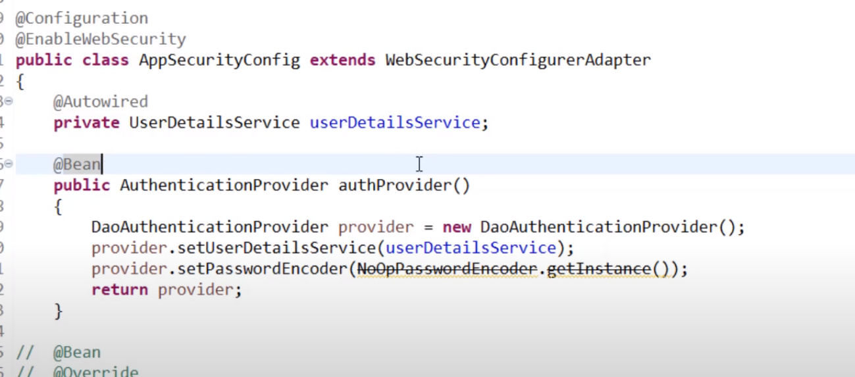

// <https://www.youtube.com/watch?v=2VKeCZsRNZk&list=PLsyeobzWxl7o-Ul7lhFb9-fLjDYapcetO&index=5>

<https://www.baeldung.com/spring-security-authentication-with-a-database>

## Custom security with custom login page

## Disabling and surpassing security

## What happen if we don’t define any passwordEncoder?

We will get exception when we give credential and try to login-

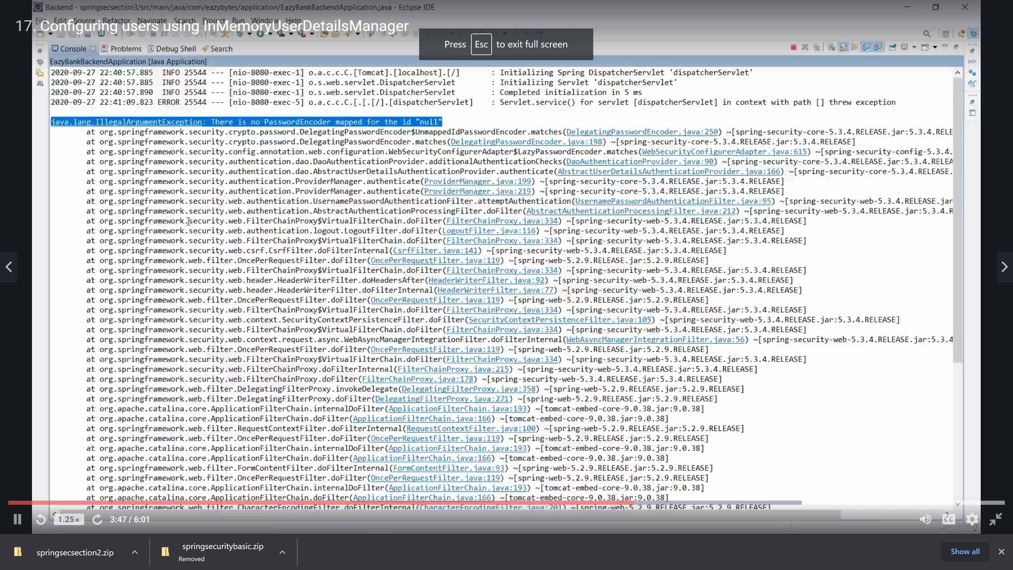

Solve this-

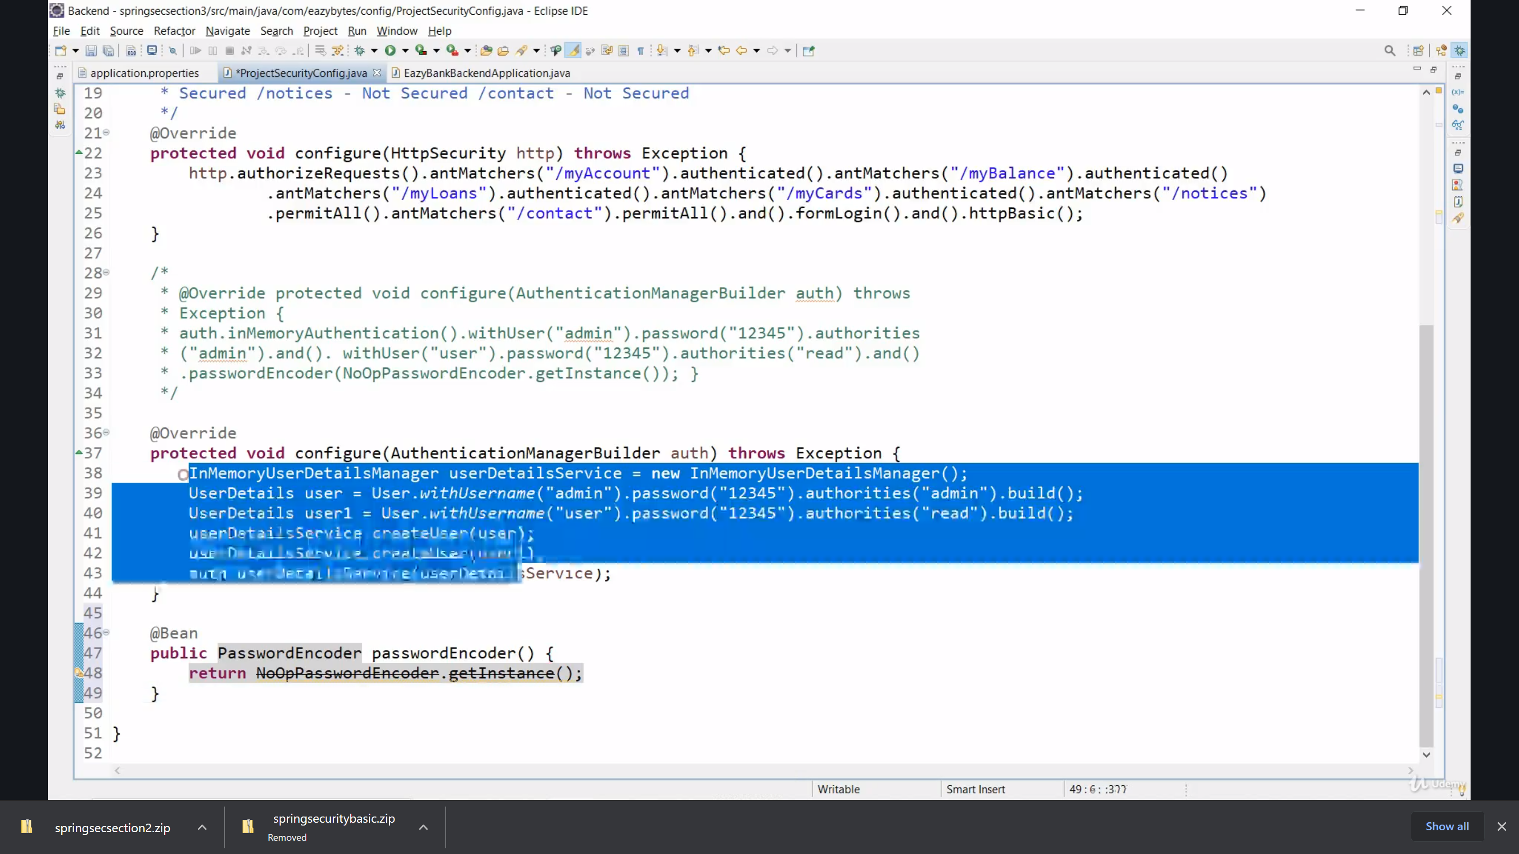

## Understanding configure methods of WebSecurityConfigurerAdapter

### **Configure(HttpSecurity) :** default implementation is as follows-

### http.

### authorizeRequests()

### .anyRequest().authenticated()

### .and()

### .formLogin().and()

### .httpBasic();

### It means by default any requeset (means all request) is authenticated and form login and httpbasic is also authenticated. Formlogin means any browser request coming from from like login form, contact form and so on. httpbasic means - any internal service means backend api we call, without input form.

1. Configure(WebSecurity)
2. Configure(AuthenticationManagerBuilder) – To build users and provide password encoder

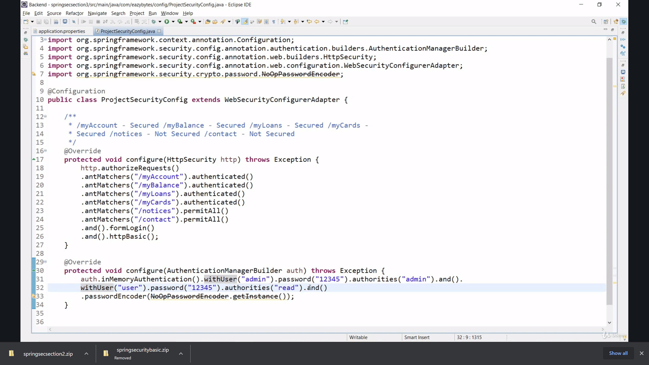

NoOpPasswordEncodedr means – no encoding for password.

## How to permitAll/ denyAll the given request?

### **Permit specific request**: Lets say we have 6 service in a banking application as – myBalance, myAccount, myLoan, myCard, notice, contact. We want to authenticated first 4 and no authentication for last 2 (notice and contact).

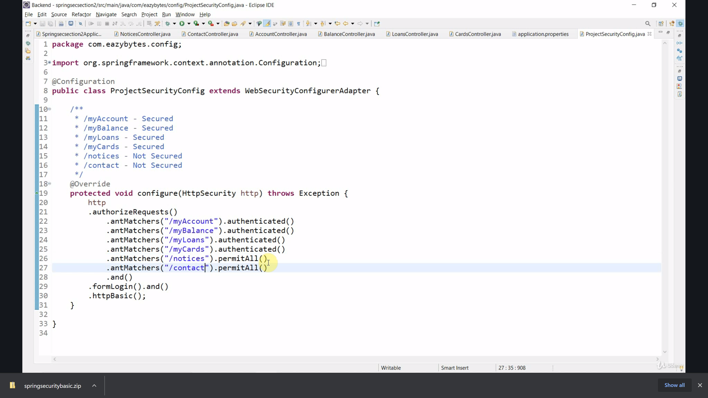

Permit ALL:

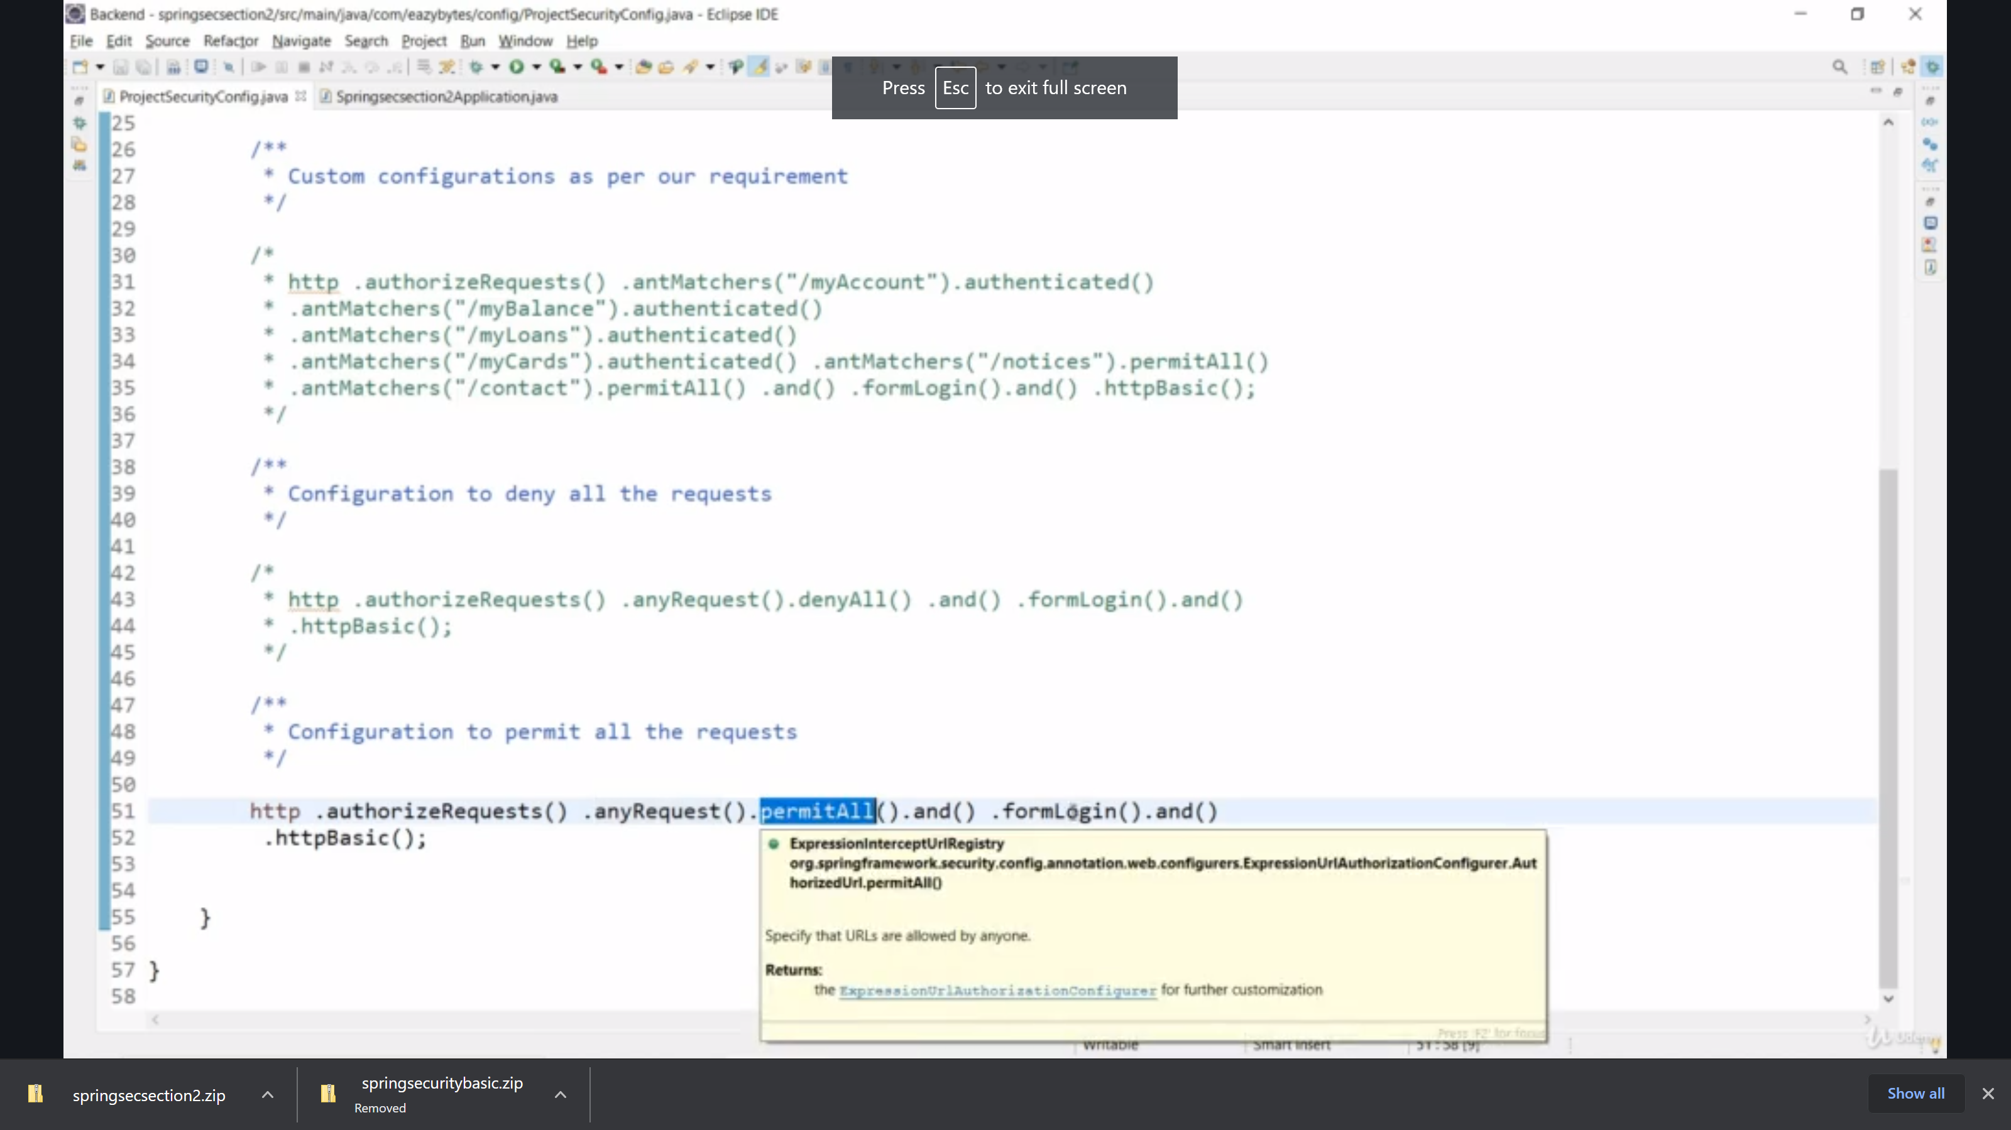

**DenyALL:**

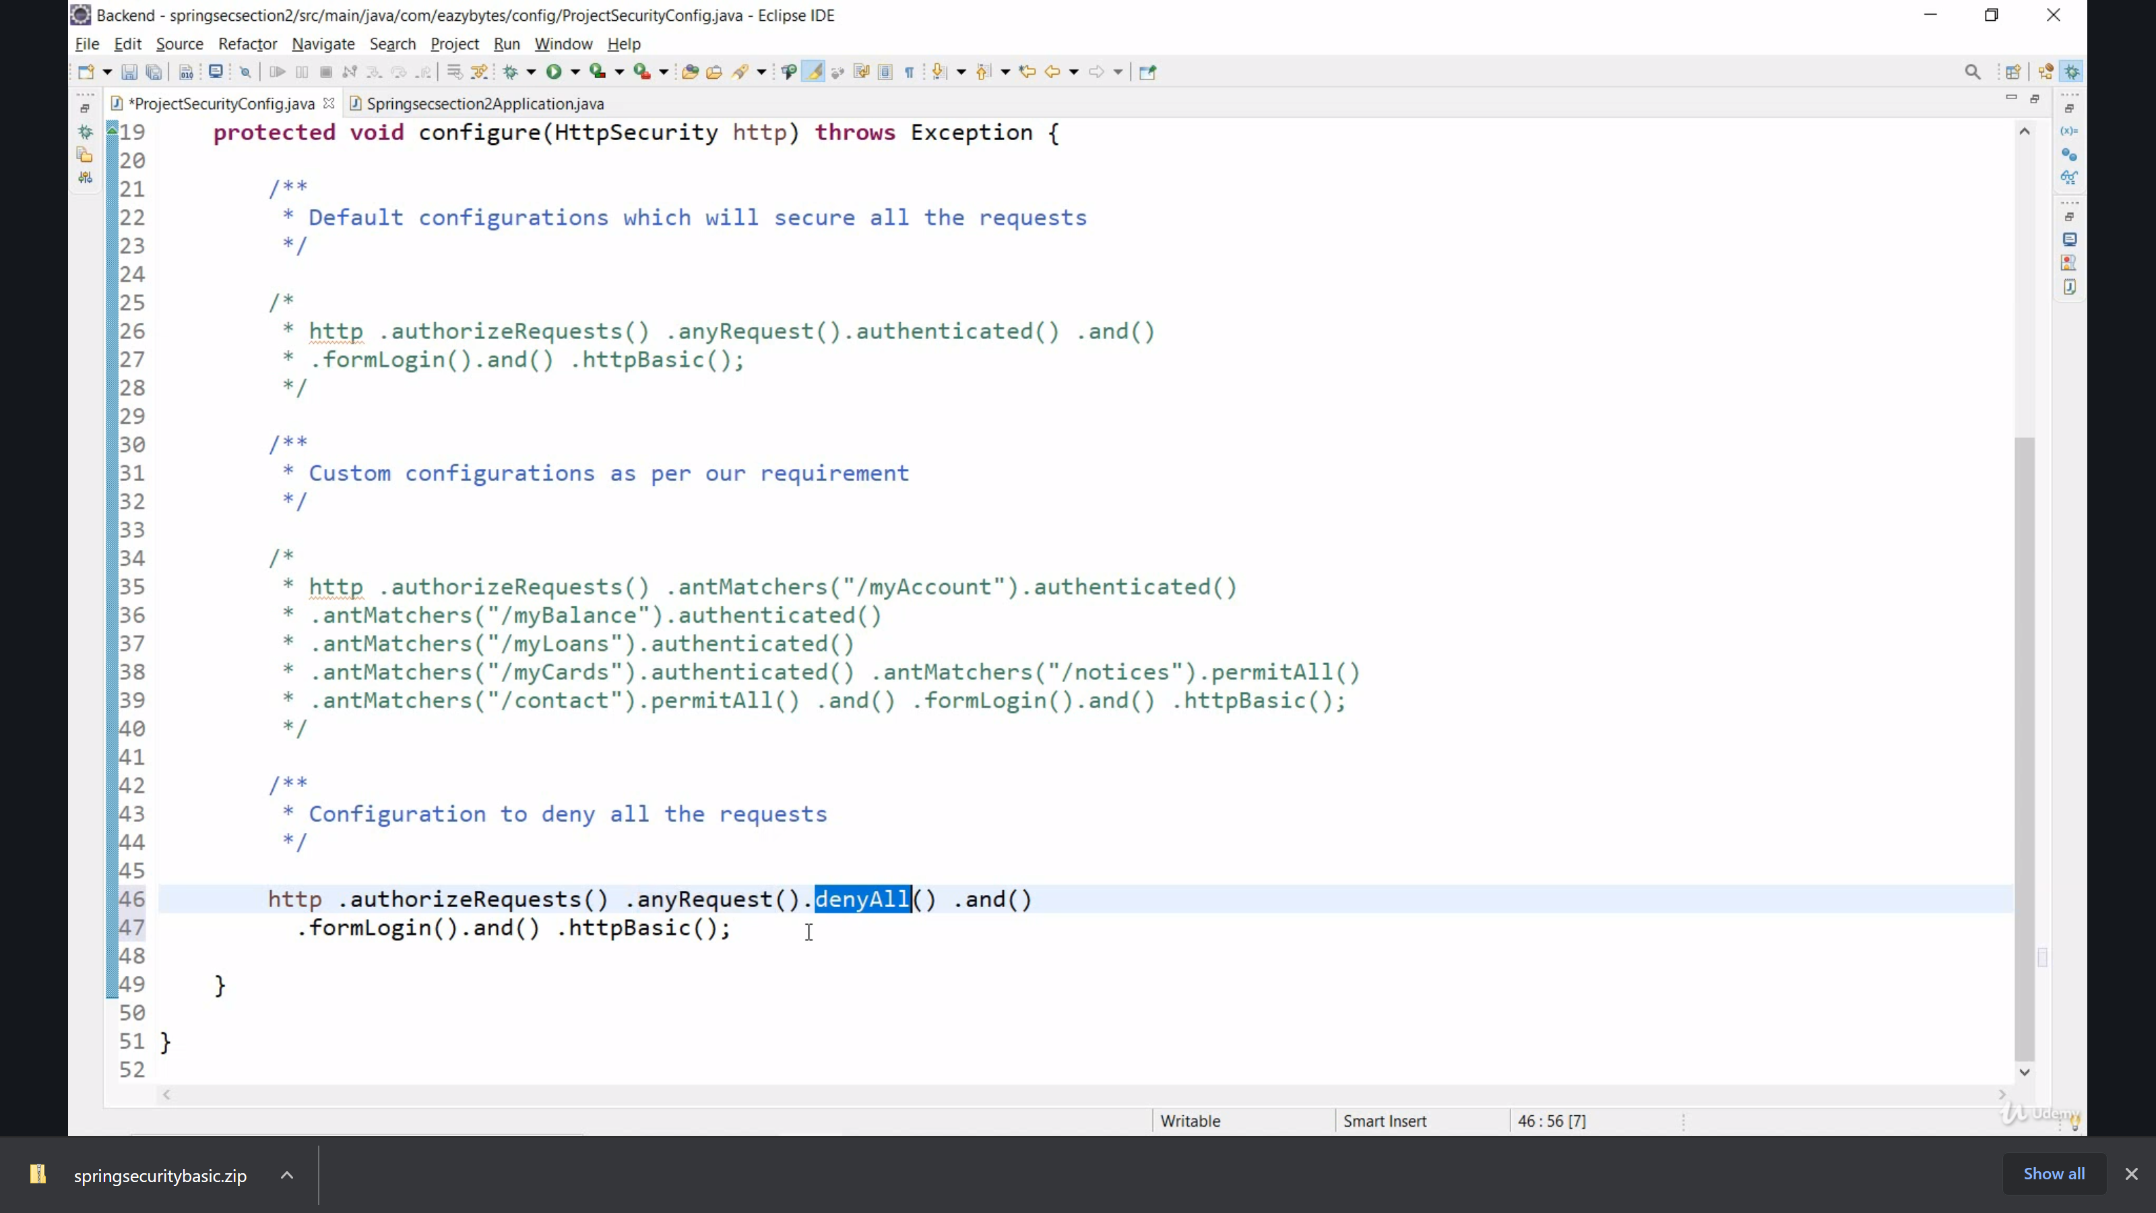

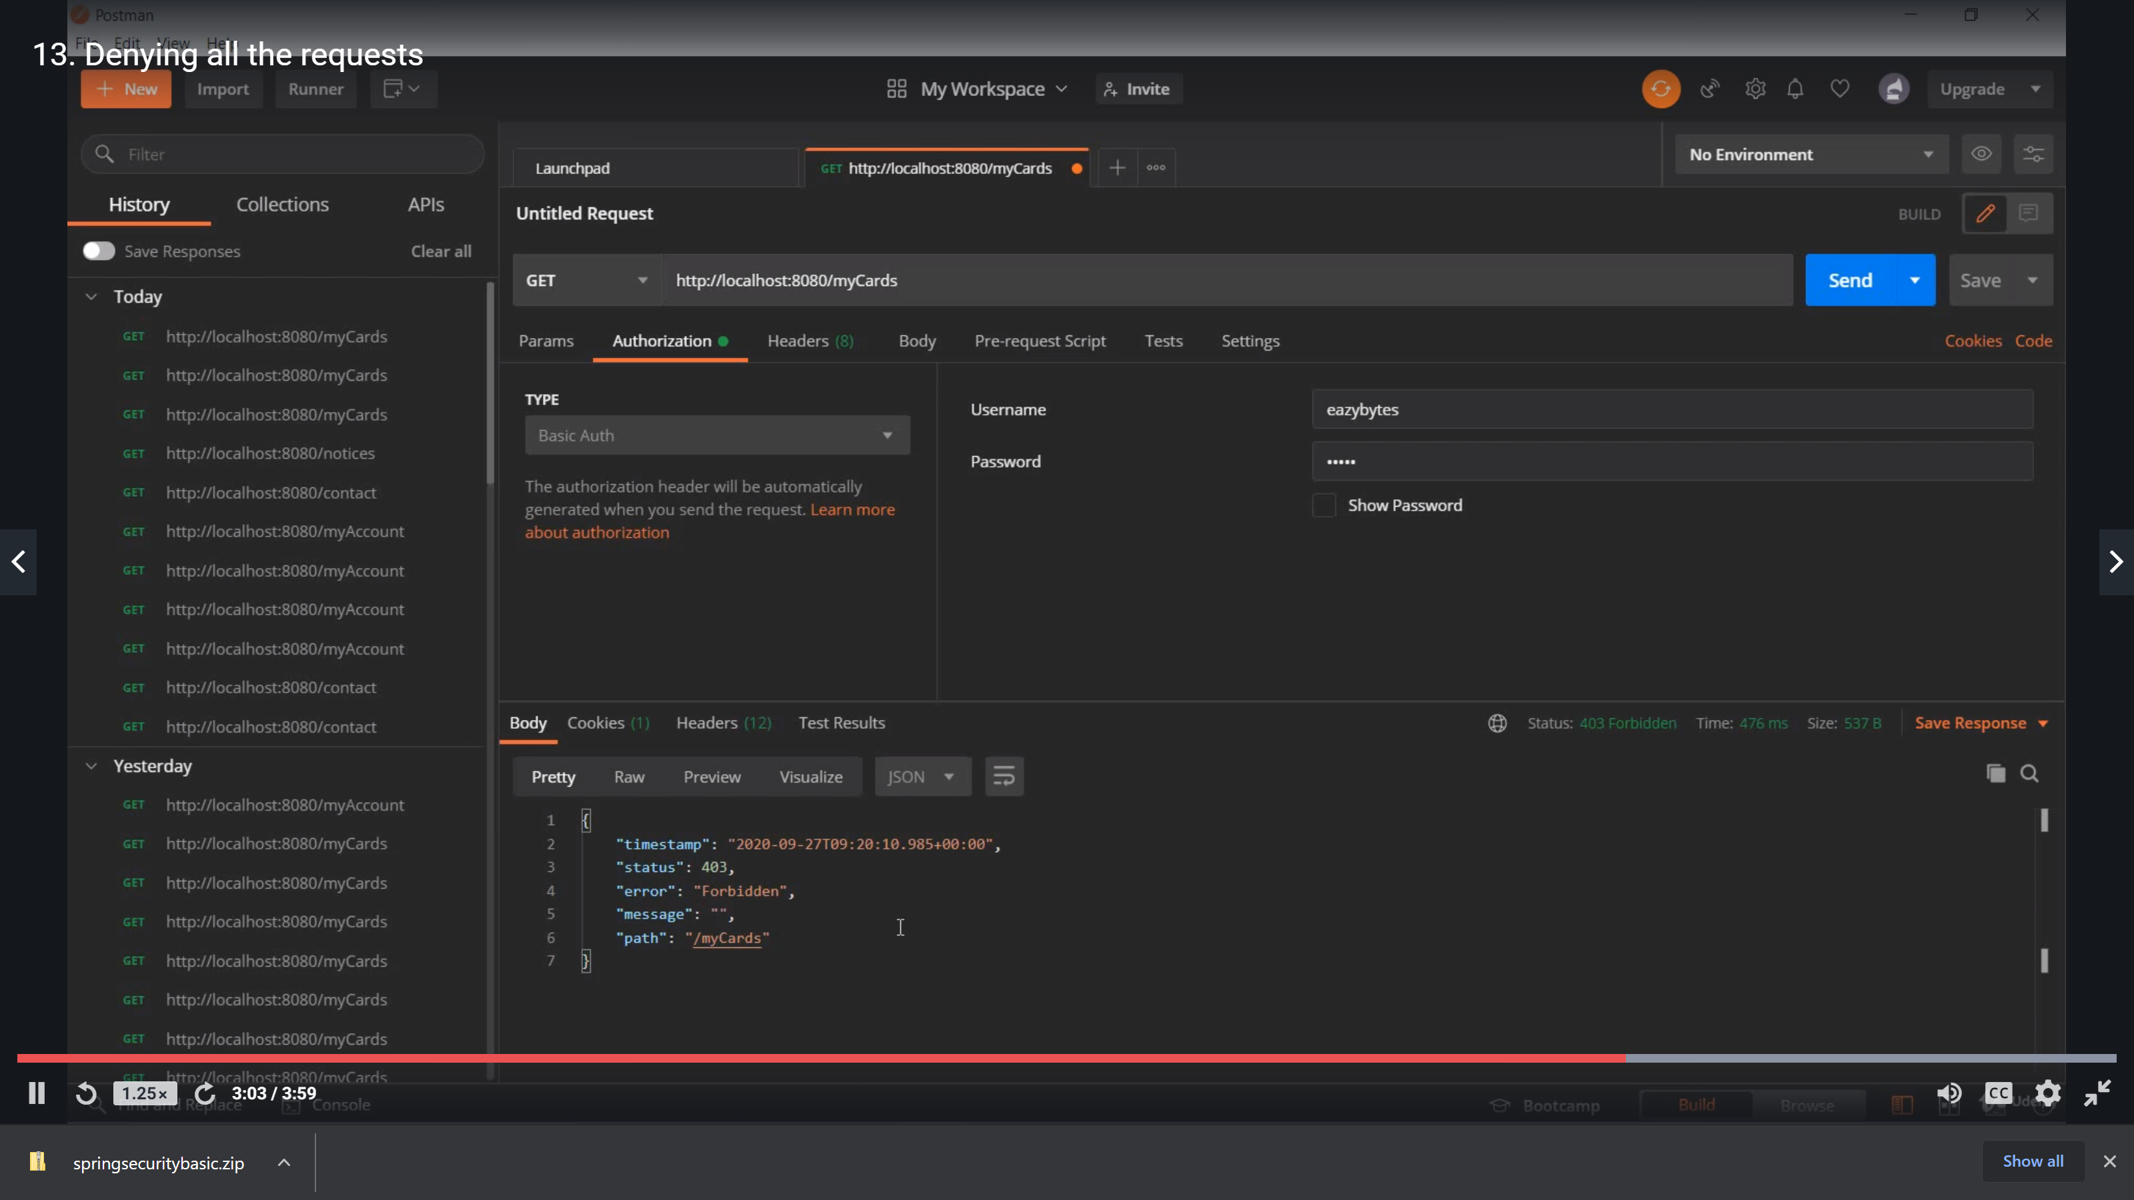

## UserManagement in spring:

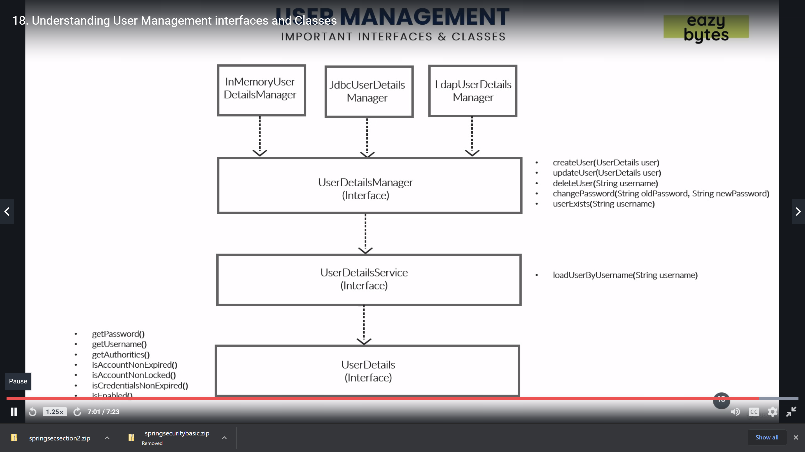

# Oauth 2.0

## Problem without oAuth2.0

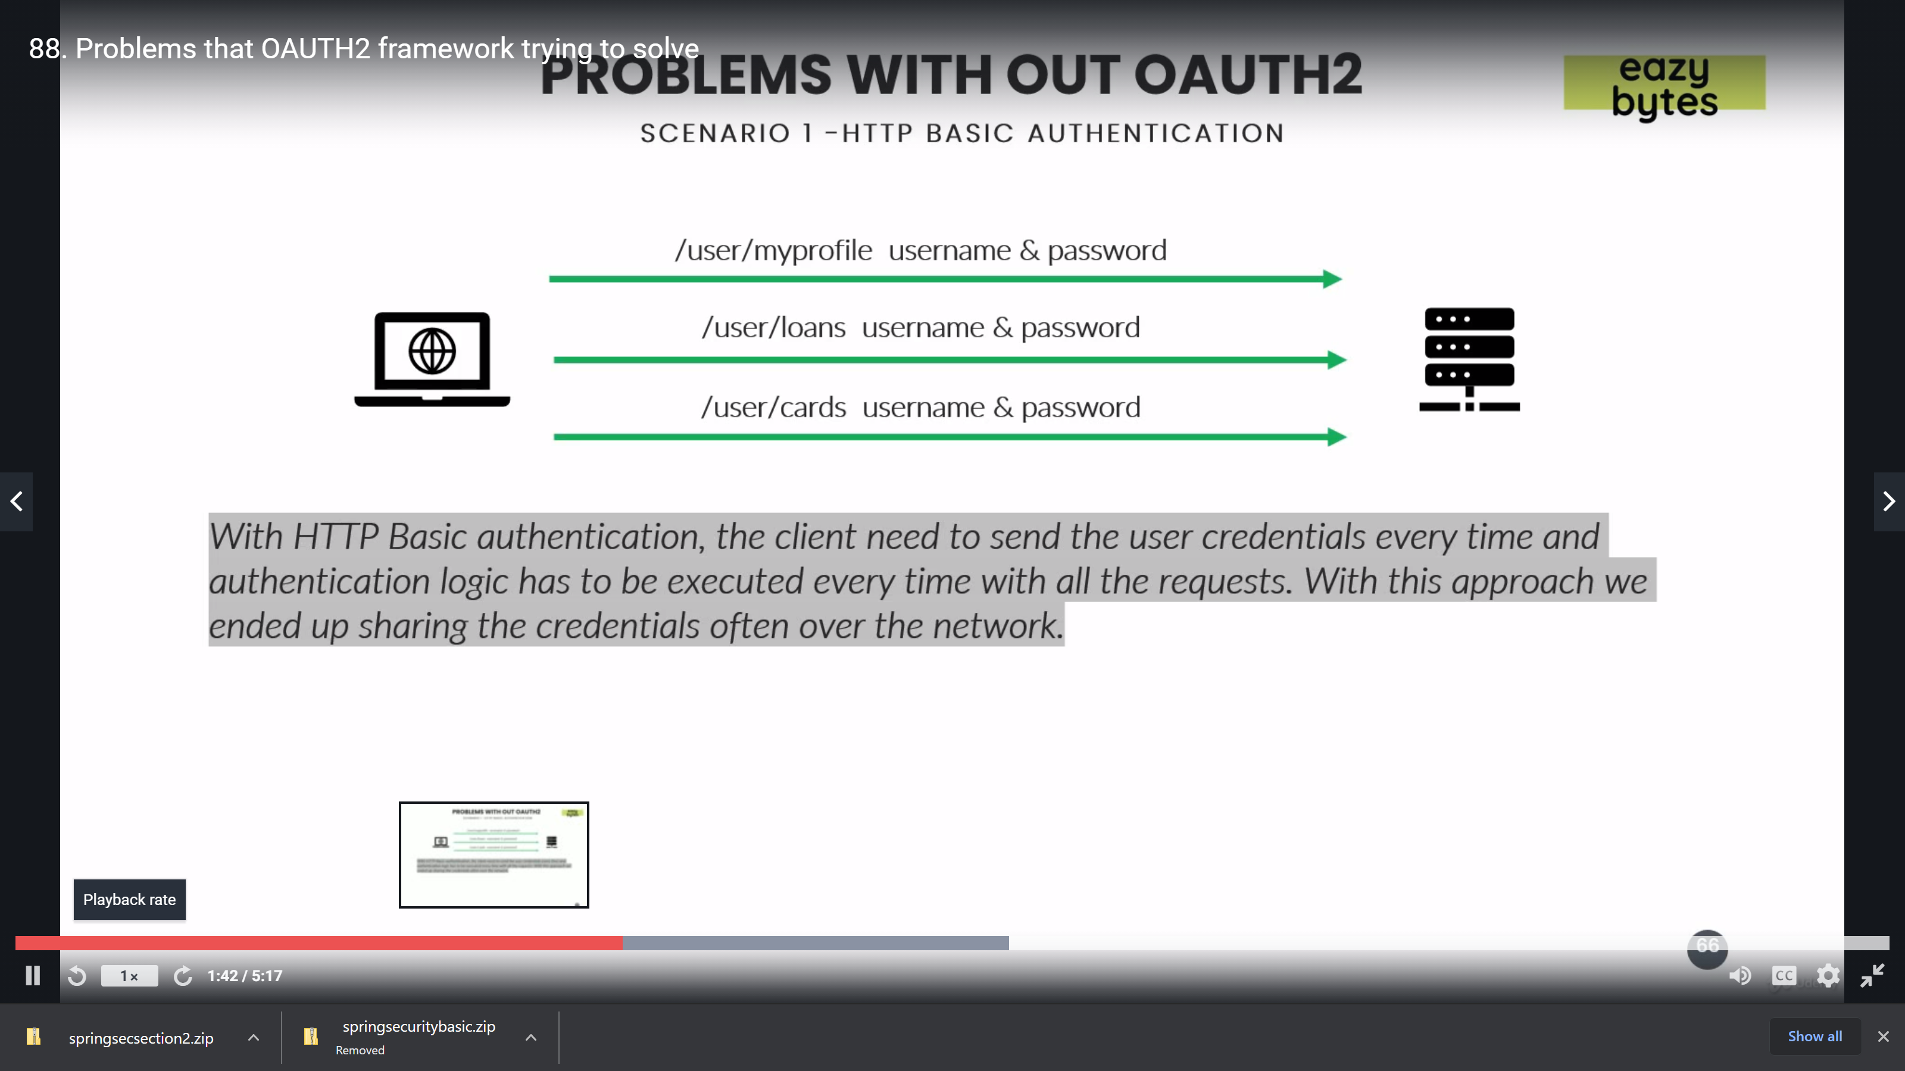

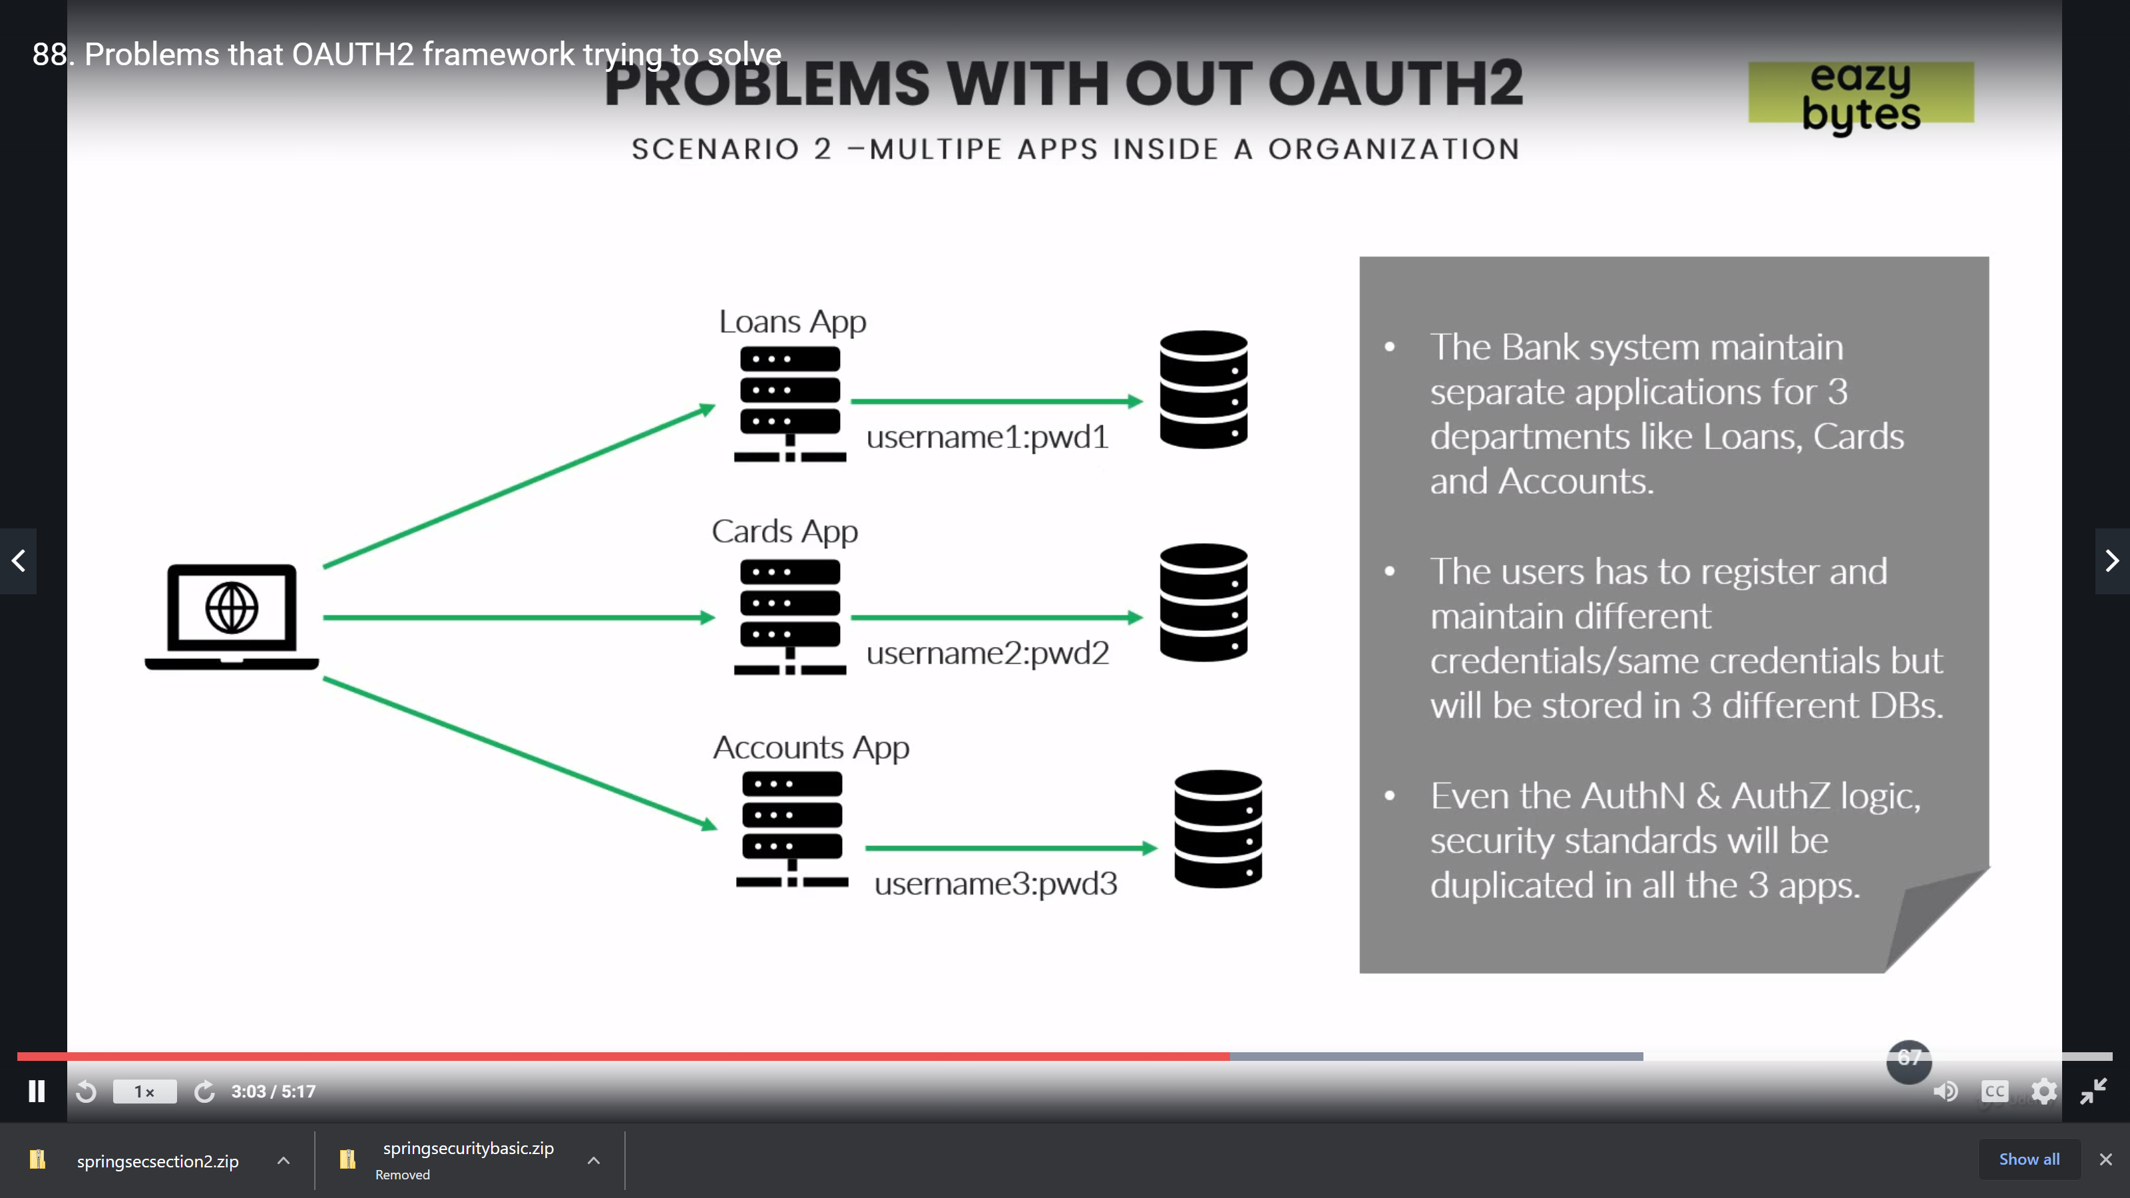

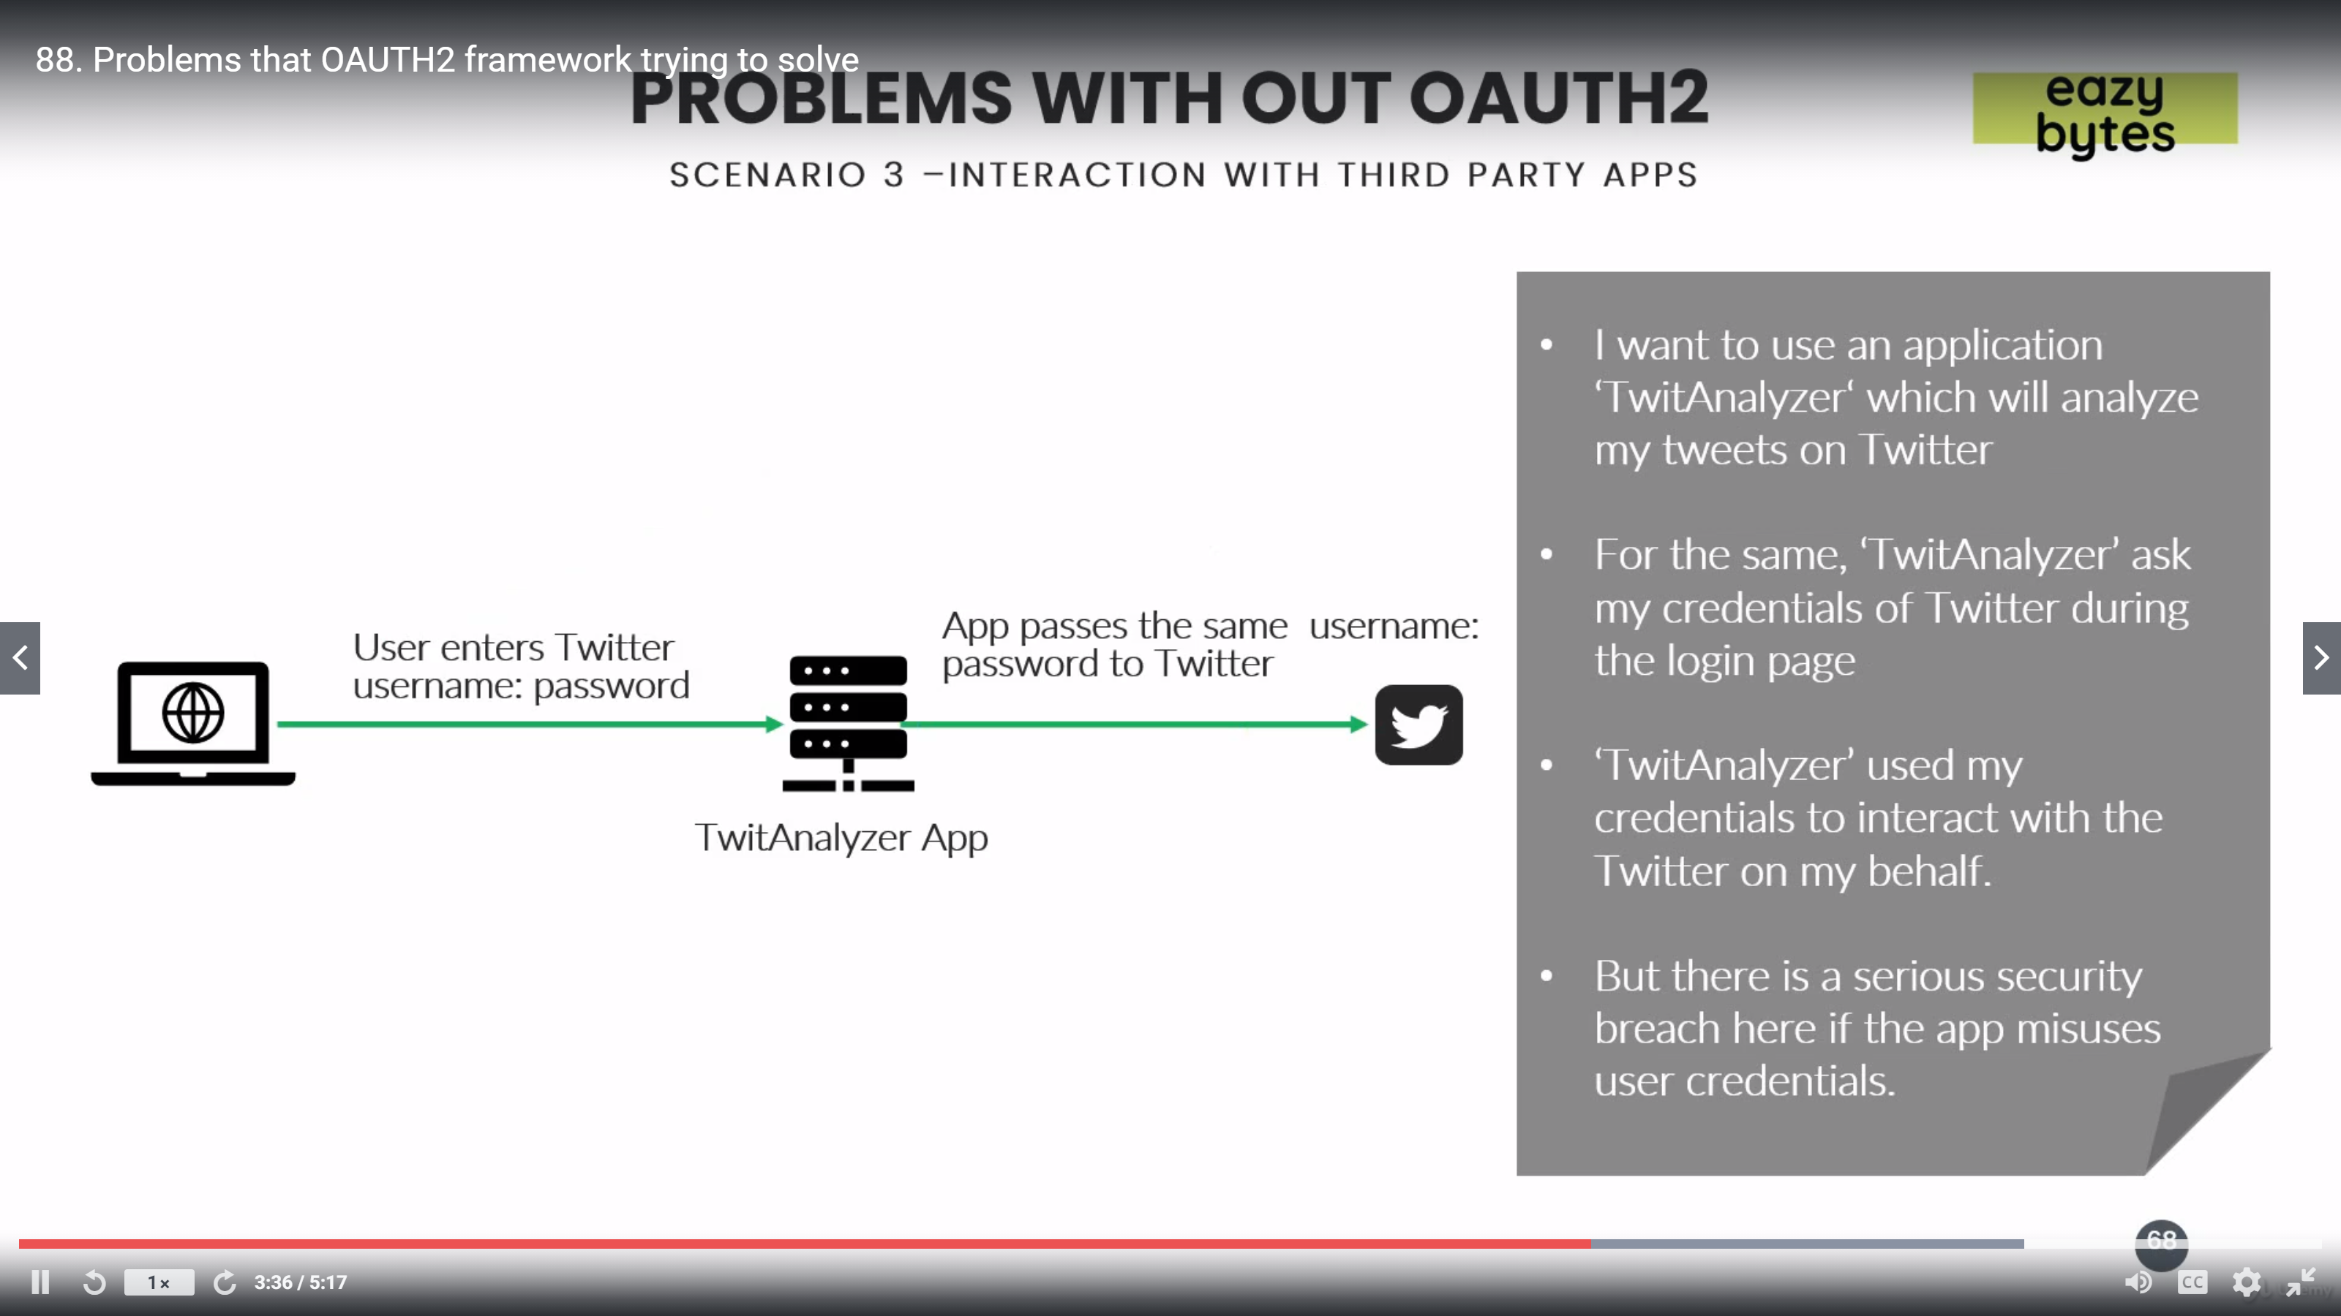

## What is OAuth2:

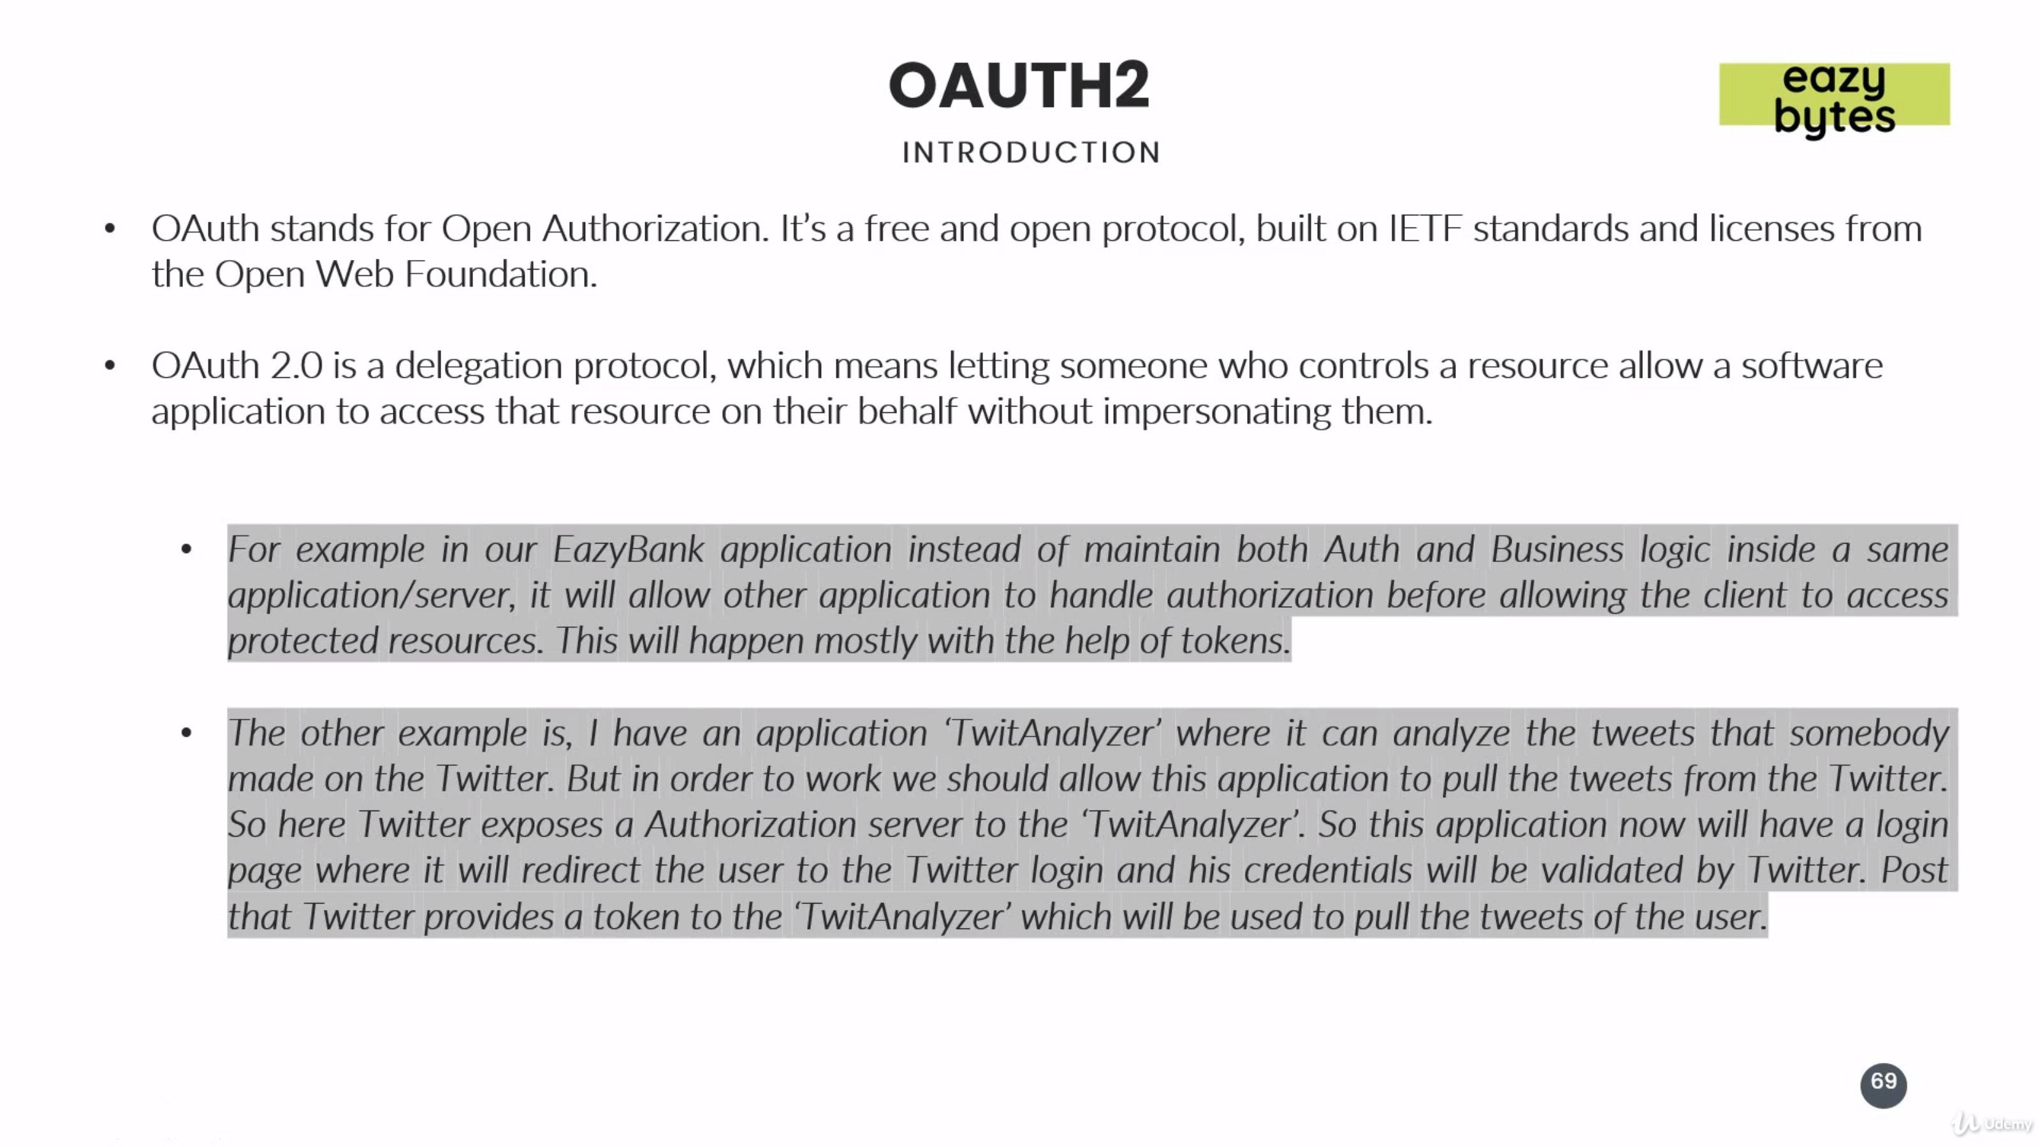

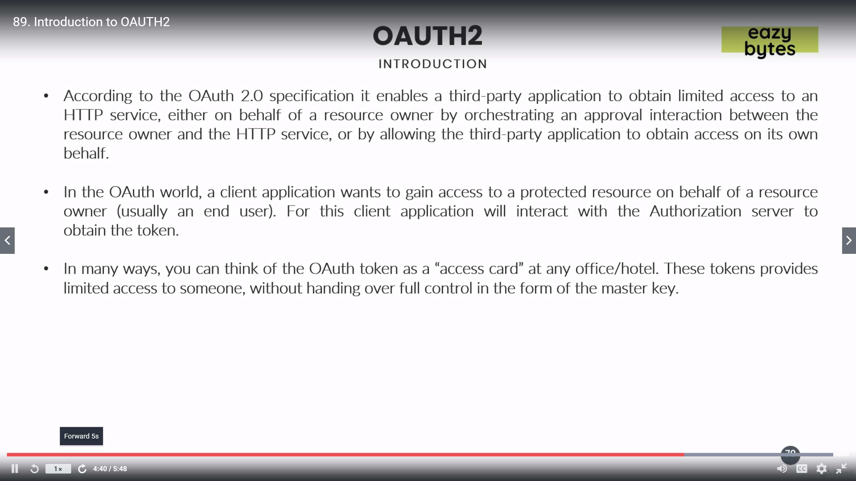

## Different Components in OAuth 2:

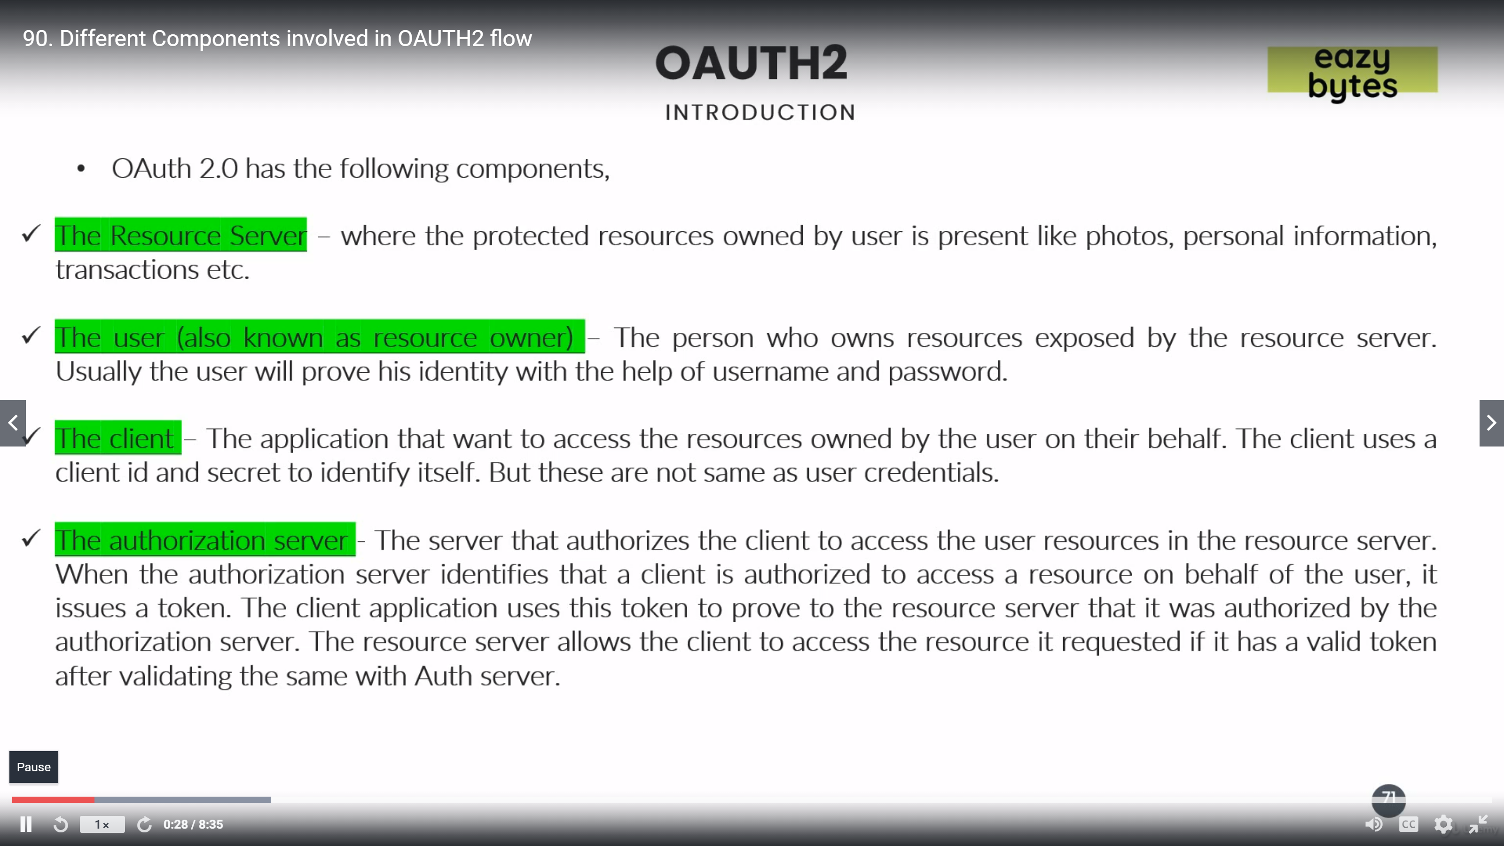

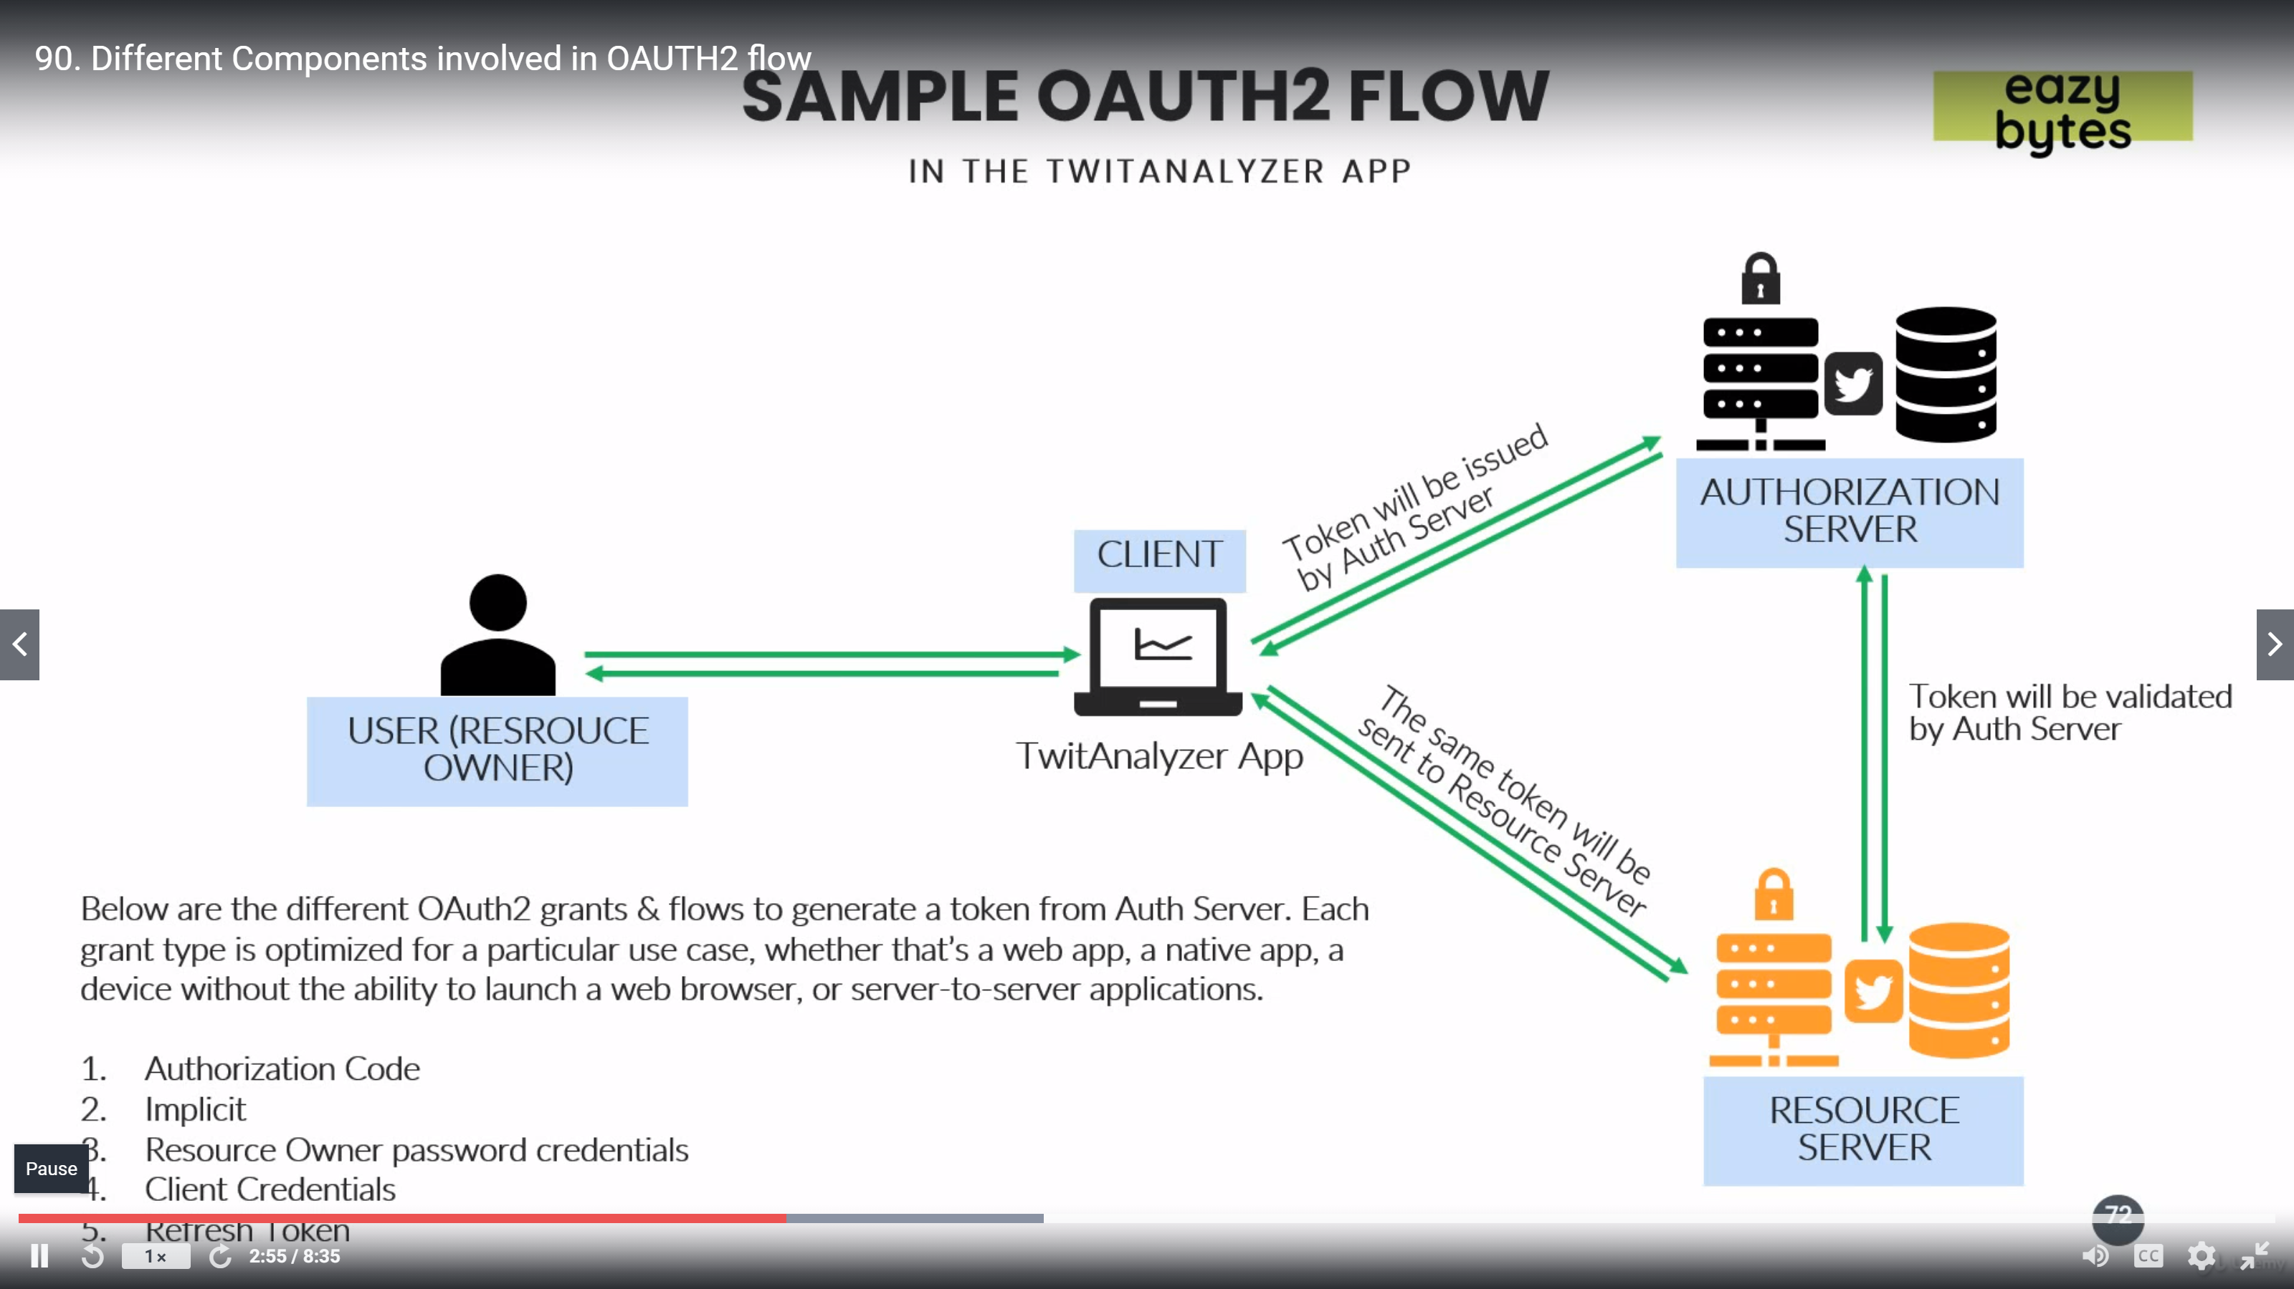

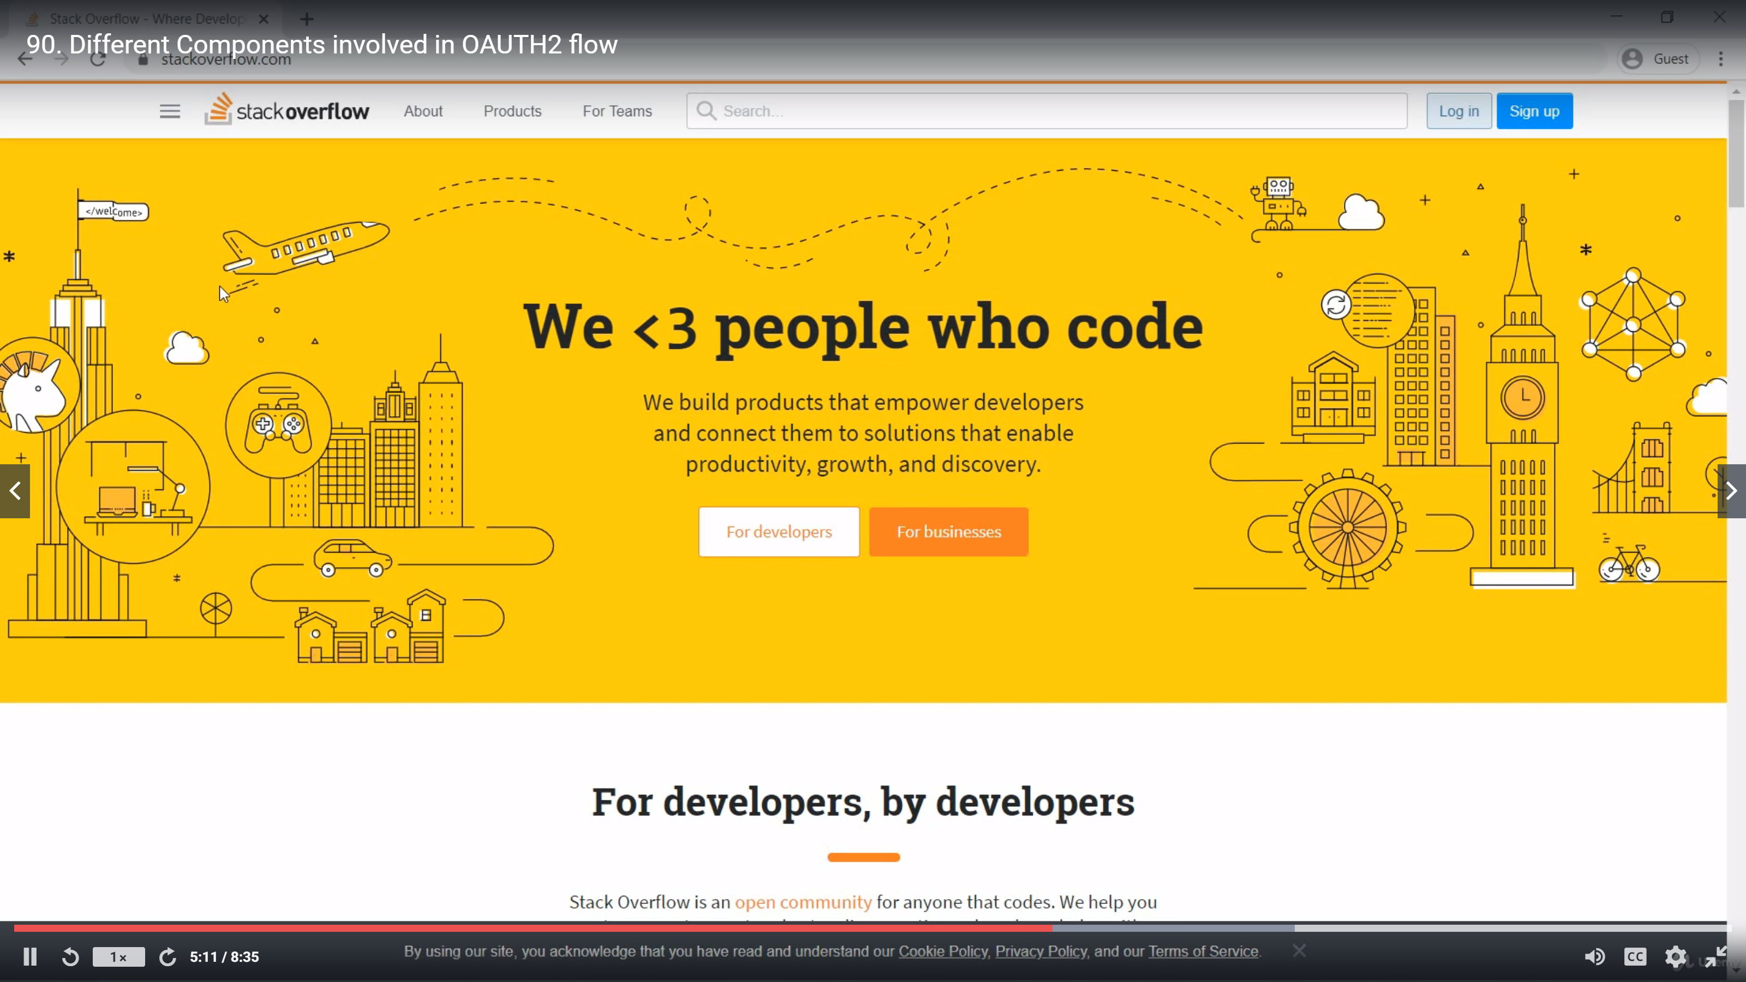

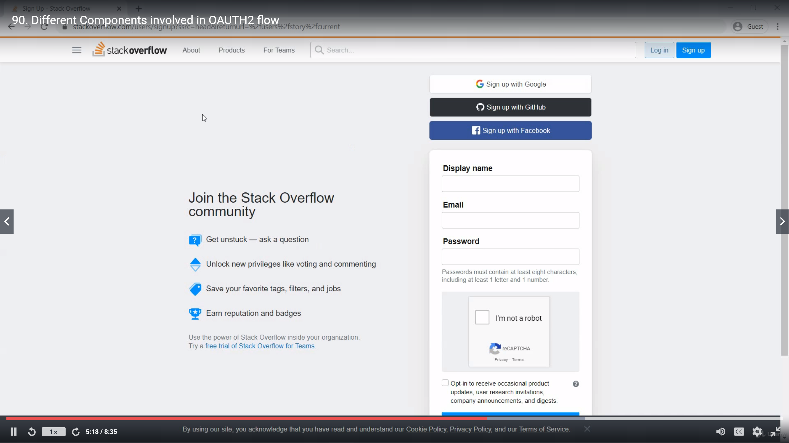

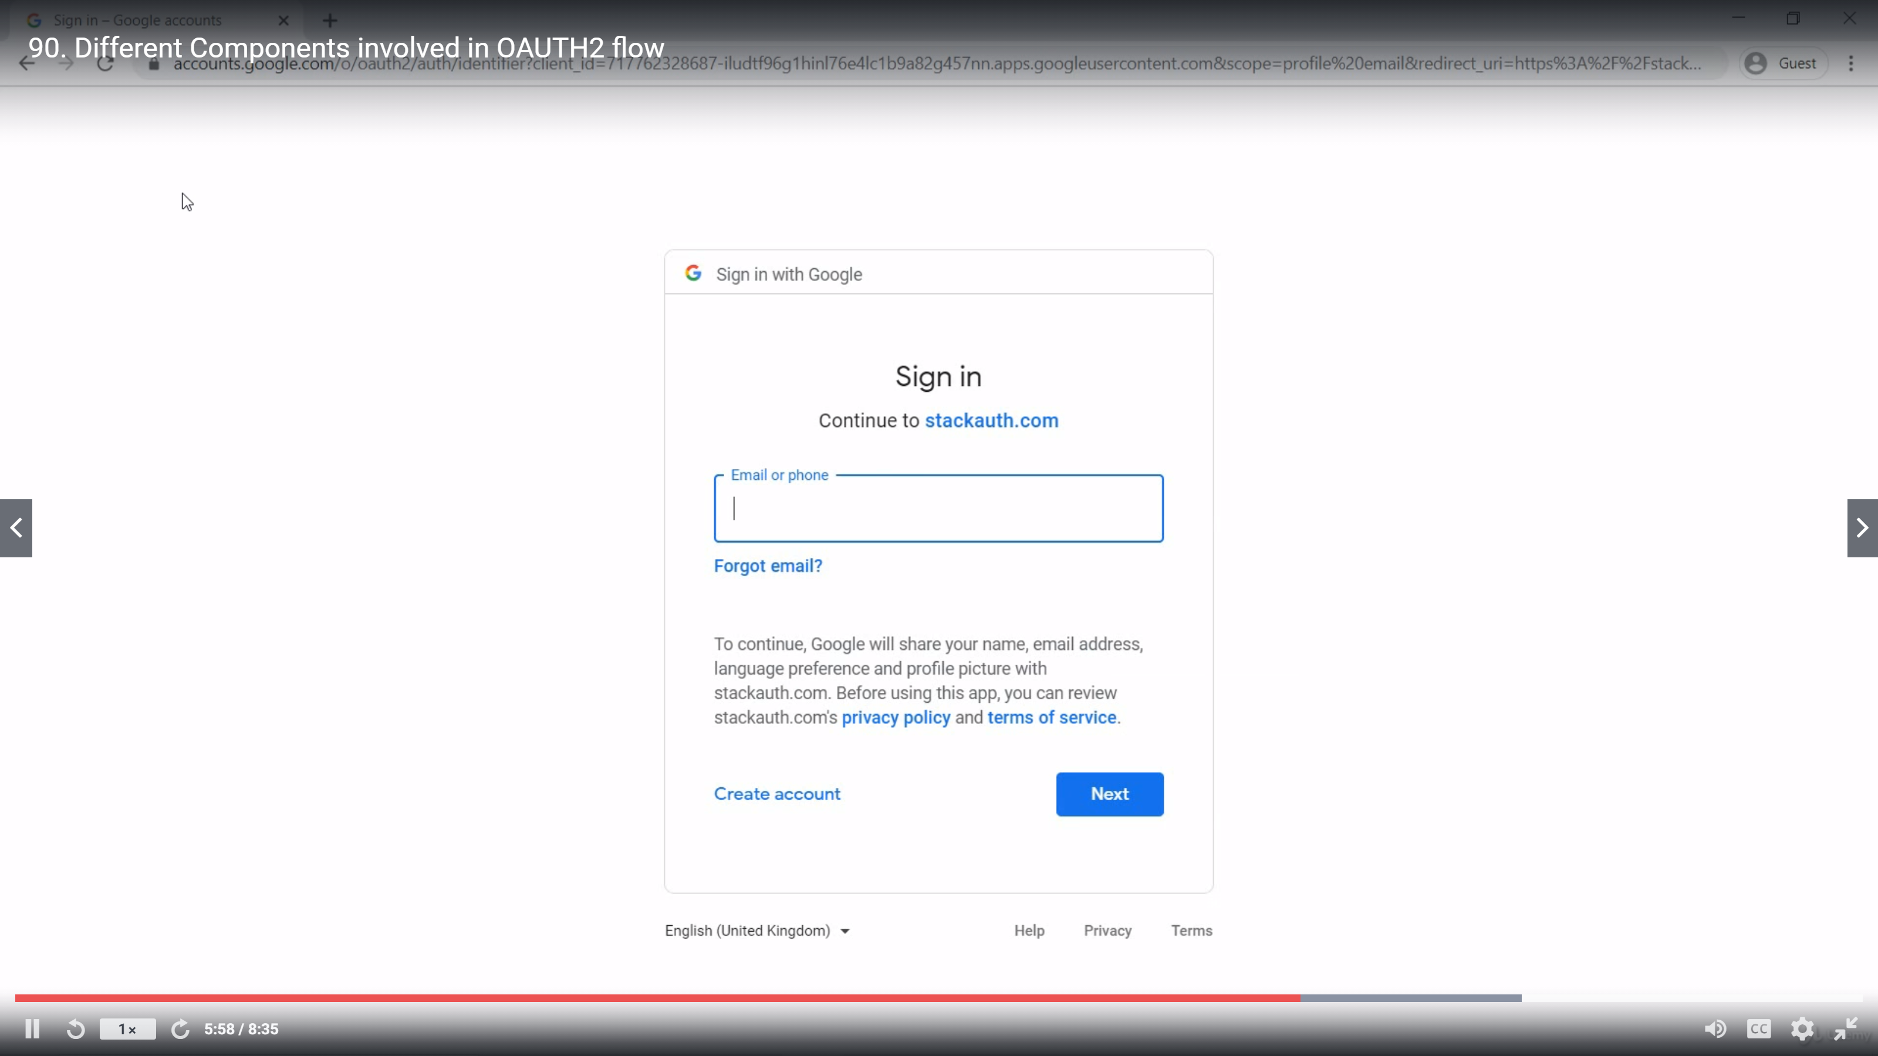

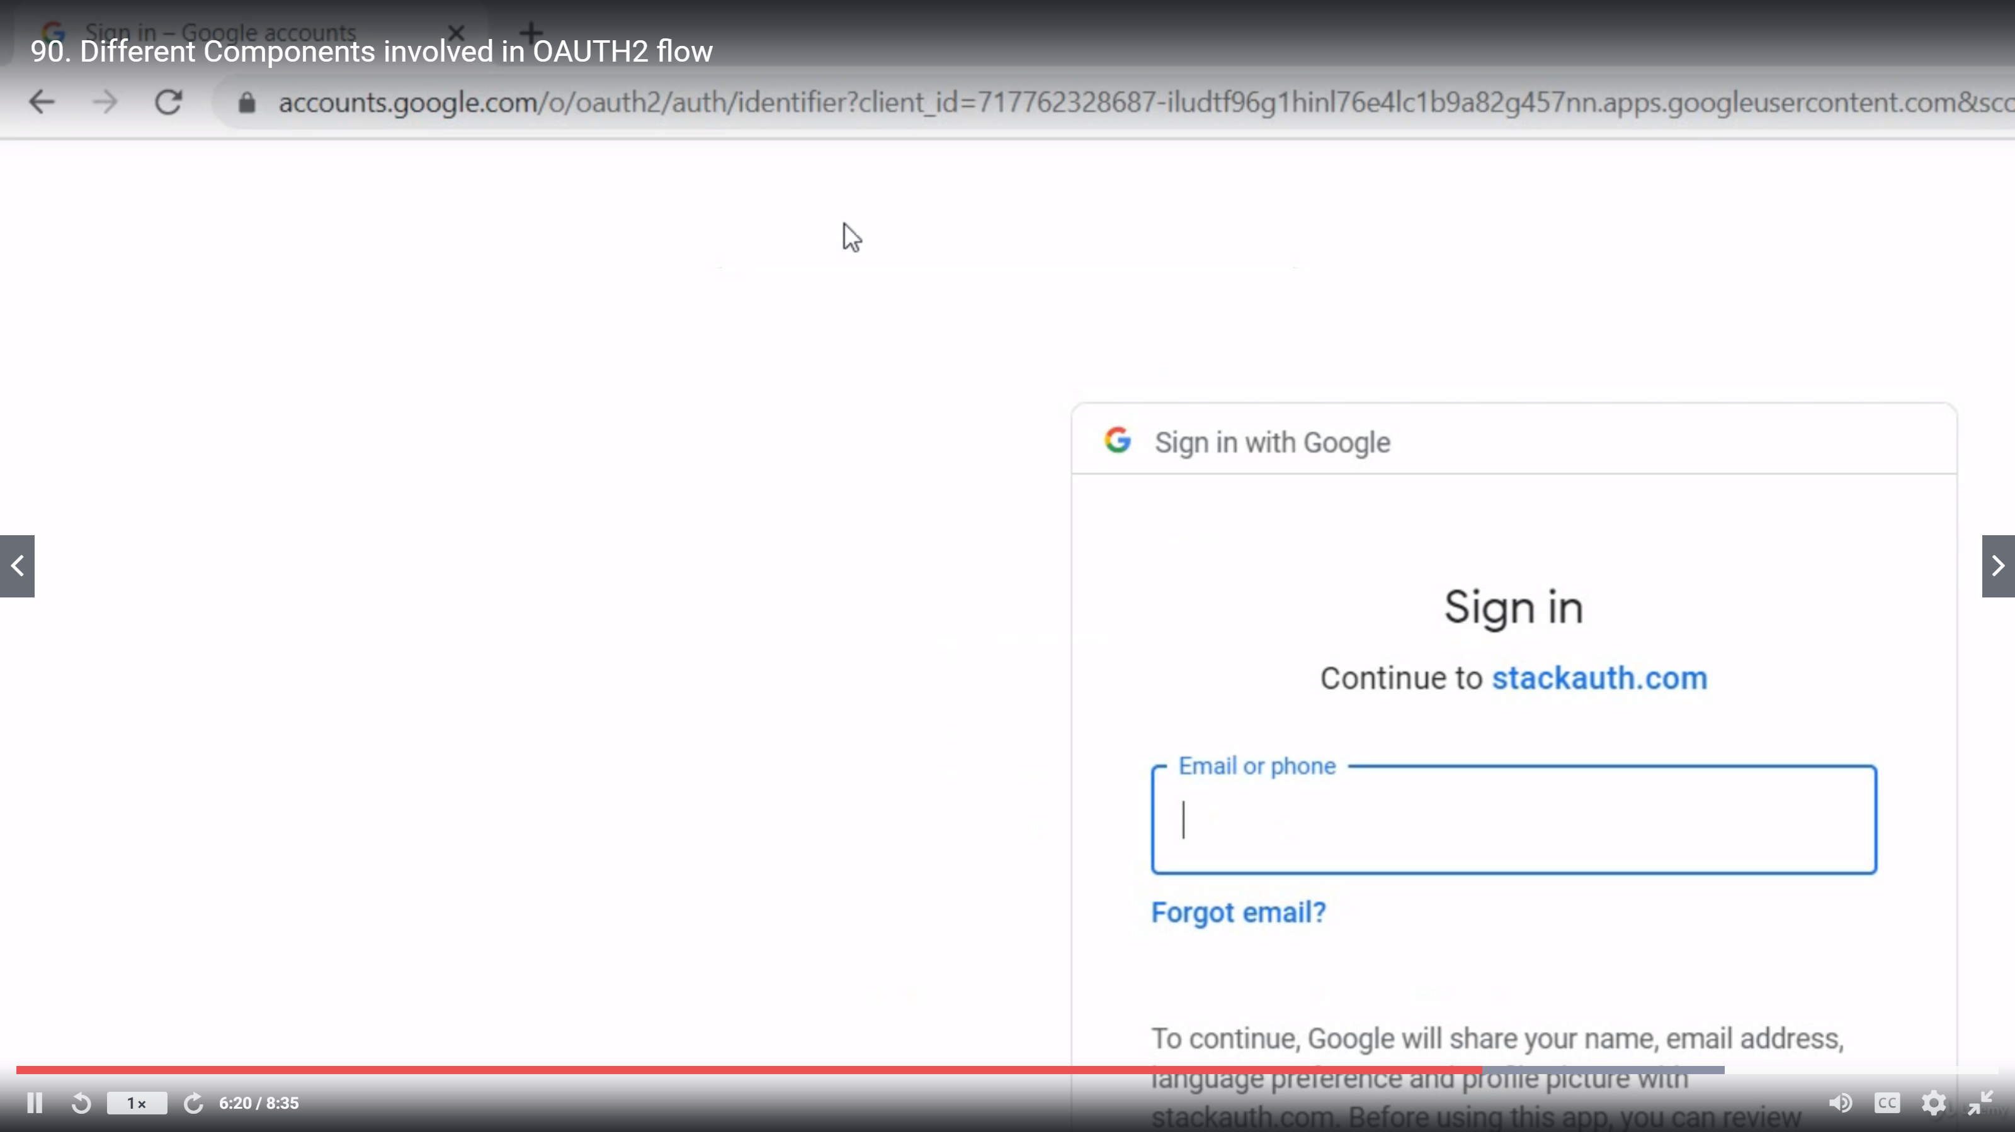

Client – StackOverflow

Resource Owner – Me (user)

Auth Srver – Google -> authorization

Resource servere – Google -> My info in Google

## Various type of grants

## Spring boot security with github as Auth server

1. Register your application to github(or any other auth server), doing this you will get client id and client secret from Github.

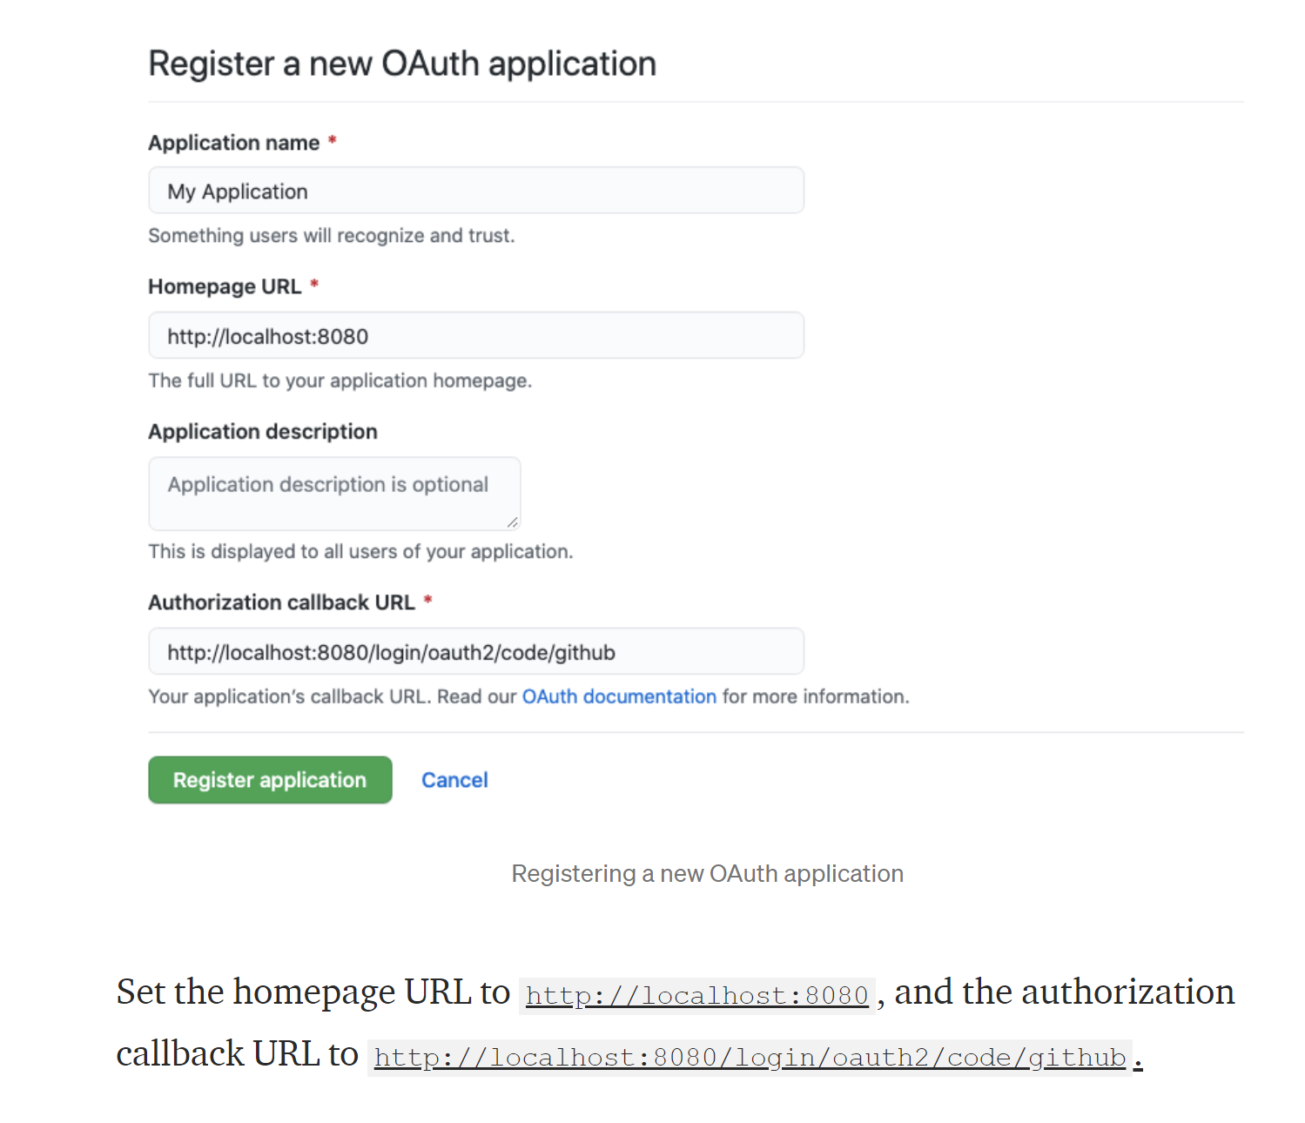

### **Authorized redirect URIs/Callback URL**: These are the valid list of redirect URIs where a user can be redirected after they grant/reject permission to your app. This should point to your app endpoint that will handle the redirect.

1. Add this dependency to pim.xml in your application.

<dependency>  
<groupId>org.springframework.boot</groupId>  
<artifactId>spring-boot-starter-oauth2-client</artifactId>  
</dependency>

1. Modify Your application ‘s application.yml/properties to contain client id and secret-

spring:  
 security:  
 oauth2:  
 client:  
 registration:  
 github:  
 clientId: ${GITHUB_CLIENT_ID}  
 clientSecret: ${GITHUB_CLIENT_SECRET}

1. Now mofify SecurityClass in your appliclation as follows –

@EnableWebSecurity  
public class SecurityConfig extends WebSecurityConfigurerAdapter { @Override  
 protected void configure(HttpSecurity http) throws Exception {  
 http.authorizeRequests()  
 .anyRequest().authenticated()  
 .and()  
 .oauth2Login();  
 }  
}

## What is authorization URI, token URI, UserInfo URI

## What are scopes in OaAuth2.0

## How to create Resource server?

## How to create Auth Server?

## Read about CommonOAuth2Provider eum and ClientRegistration class in Spring 5

1. use-security-oauth2 in pom.xml for oAuth2.0
2. OAuth components:
   1. Authorization server
   2. resource owner,
   3. resource server,
   4. client

an OAuth 2 authorization server is responsible for managing client details, verifying a resource owner’s authorization, and generating tokens such as authorization code, access, and refresh tokens.

**GRANT TYPE:**

**Authorization Code:** used with server-side Applications

**Implicit:** used with Mobile Apps or Web Applications (applications that run on the user's device)

**Resource Owner Password Credentials:** used with trusted Applications, such as those owned by the service itself

**Client Credentials:** used with Applications API access

## Reference

### <https://www.javainuse.com/spring/boot_security_jdbc_authentication_program>

### Telusko you tube

### Beldung